WORK IN PROGRESS

TEAM MEMBERS

Arju Adhikari

Nimisha Raut

Sajil Maharjan

MD Aashif Ansari

***logo***

Table of Contents

1 Initiation Phase 3

1.1 Project Charter 3

• Version Control 3

• Project Justification 3

• Project Scope 3

• Duration 5

• Estimated Budget 5

• Roles and Responsibilities 5

1.2 Team Contract 6

1.3 Team Meetings 11

2 Planning Phase 19

2.1 Skill Audit 19

• Team Skill Audit 19

• Individual Skill Audit 22

2.2 Project Management (MS Project) 26

• Gantt Chart 26

• Timeline 28

• Task Sheet 28

• Calendar 30

• Resource Sheet 32

• Change Working Time 33

**2.3** **Communication Tool Used** 34

• GitHub 34

• Discord 34

• Google Meet 36

3 Execution Phase 37

3.1 Entity Relationship Diagram 37

• EERD 37

• ERD 38

• Final Composite/De-composite 39

• Logical Table 39

3.2 Use Case Diagram 40

• Overview Use Case Diagram 40

• Customer Overview Use Case Diagram 41

• Trader Overview Use Case Diagram 42

• Admin Overview Use Case Diagram 43

3.3 Requirement Catalogue 44

• Functional Requirement 44

• Non-Functional Requirement 46

3.4 Logo Design 47

3.5 Wireframe 47

• Customer Interface 47

• Trader Interface 47

• Admin Interface 50

3.6 Product Development 53

• Homepage 53

• Login 53

• Register 53

• About Us 53

• Backend 53

# Initiation Phase

## Project Charter

|  |
| --- |
| Project Title: Phoenix Mart |

### Version Control

|  |  |  |
| --- | --- | --- |
| Version | Date | Summary of changes |
| 1 | 22/02/2022 | Starting phase in lead for the building of project. |
|  |  |  |

### Project Justification

|  |
| --- |
| ﻿  The opening of a convenience store has challenged the small independent businesses in the suburbs of Cleckhuddersfax. Understanding the reason behind the extended service hours provided by convenience stores, traders aim to create a platform that will provide exclusive service to locals who could not purchase goods during the conventional opening time. A modern online purchase service is formulated as a solution, thereby letting the locals buy goods remotely without having their working hours collide with the opening hours of the local stores and, at the same time, without having the traders compromise on their family time.  The website provides top-notch 24/7-hour services to the customers, withholding its long-time value to serve local quality goods, now on the tip of their fingers, covering devices ranging from mobiles to computers. The modern approach to shopping via E-Mart provides the facility to order products after registration. The amenity of logging in and adding products to the cart is featured. A showcase of products and their descriptions of calories and daily intake is displayed. Finding the perfect product for the customer is easier with the search engine service added. Customers can find the best-fit product for them as they can define their range of criteria for a product and use the search and sorting system. Collection of the order is possible three times a week from a collection center as per their decided collection slot, and payment via PayPal. Understanding the significance of feedback for quality control, it also contains a section for reviewing and rating the products directly by customers.  The website design stabilizes the two sides of the Cleckhuddersfax seesaw: customers and traders, ensuring the delivery of local organic products by the traders and their intake by the customers, resulting in work-life balance and a growing community that is firmly apt for the preservation of their historic heritage yet accepting of modern approaches to leading a business. |

### Project Scope

|  |
| --- |
| **Specific**   * ﻿Single Medium for varied users to buy, sell and manage products according to the individual role. * ﻿Application of a wide range of unique functionality ensures customers have a better user experience as they navigate to find the best fit product. * Comfortable services are available for the customers at their fingertips while assuring quality local products at a reasonable price.   **Measurable**   * ﻿Provision of the report for the traders to track and extract meaningful information. * Keeping a tab on order count and its associate payment. * Overview of the entire project through the view of the dashboard.   **Achievable**   * ﻿Facility to search and sort the products as they can define their range of criteria. * Quality control by providing functionality to review and rate the products. * Facility for unregistered users to add products to the wish list. * Functionality to log in, register for new users.   **Relevant**   * ﻿Supervision of sale for analysis and its utilization for the growth of their business. * Extraction of changes that are essential for upgrading end-user experience by surveying the review and comments. * Pictorial representation of different statistically representable data provides a quick analysis at a glance.   **Time**   * Project Start Date [22/02/2022] * Project Deadline [15/05/2022] * Ordered products are collected from a shop point after 24 hours of placing an order and it can be picked every Wednesday, Thursday and Friday on slot basis. |
| **Customer Interface**   1. ﻿The interface is primarily set for 5 traders however it supports a maximum of 10 2. Search bar and flexible sorting mechanism to find optimum product. 3. Description of each product such as its name, price, nutrition values, and allergy catalog. 4. A responsive interface allows users to access the site while using a wide range of browsers and devices. 5. Each registered user is equipped with a single cart and it can hold products from any traders. 6. Products added to the wish list during the logged-out state will be updated to the account after the user logs in or registers. 7. A wish list is manageable by both registered as well as non-registered users providing a platform to attract new users and increase engagement. 8. Registration as well as an edit of personal information can be done only after email verification. 9. Secured well-designed and effectively navigated website design. 10. After slot selection, products overview and its price are displayed for final confirmation from the customer ensuring selection of the right products. 11. The order summary is sent to the user via email after payment is done. 12. Transparency throughout the delivery process results in better assurance and a trustful relationship between customers and the traders. 13. Modal view to have a quick display of the product along with a feature to order the product.   **Trader Interface**   1. ﻿View their detail and make changes. 2. Provision of information and product management using CRUD operation. 3. An interface for the track of customer's order detail provides the feature to view using different filter options. 4. Login feature allowing to view their reports covering different aspects such as orders, stock levels, sale amount.   ﻿**Management Interface**   1. ﻿Admin login interface. 2. Capability to manage accounts of all 5 traders. 3. Access to view daily and periodic Dashboard reports on different statistically representable data of all the traders. 4. Provision for inspection and quality control of the products distributed by the traders using traders' activity log system. 5. Provide weekly delivered order reports stating payments to be made by the traders. 6. An interface displaying a record of all the site visit users. |

### Duration

|  |
| --- |
| Initiation week – [22/02/2022]  Planning phase week – [02/03/2022]  Executing phase week – [03-06-2022]  WIP date – |

### Estimated Budget

|  |
| --- |
| Hours per day per person 4-5  Total team consists of 4 Members  Overall hours:  4*7*4*12= 1,344 hours (Min)  5*7*4*12= 1,680 hours (Max) |

### Roles and Responsibilities

|  |  |
| --- | --- |
| Name | Role |
| Arju Adhikari |  |
| MD. Aashif Ansari |  |
| Nimisha Raut |  |
| Sajil Maharjan |  |

## Team Contract

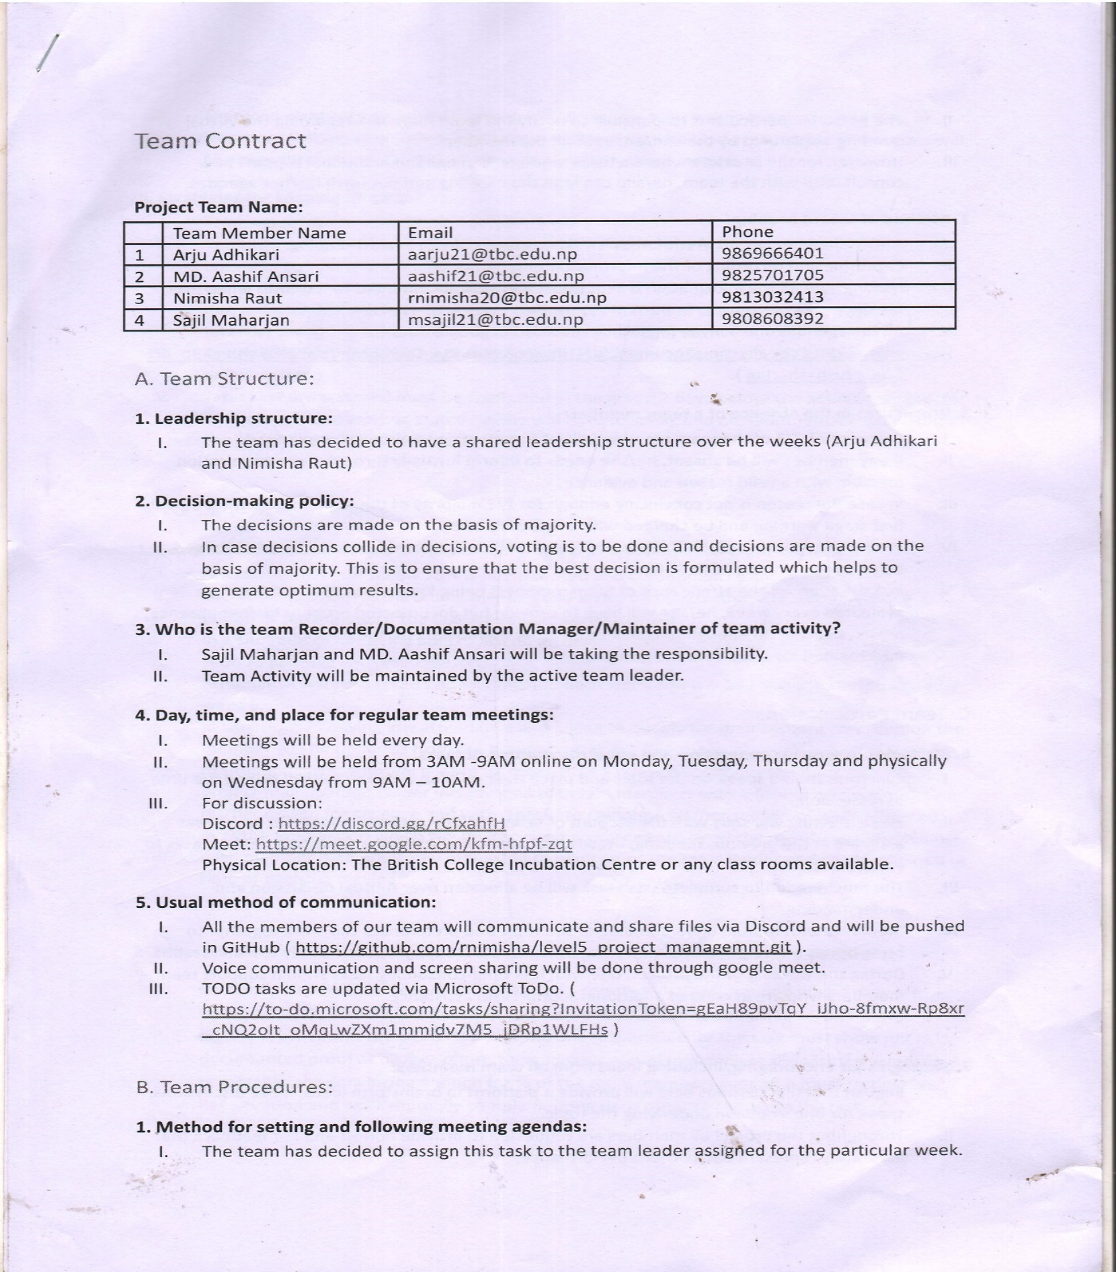

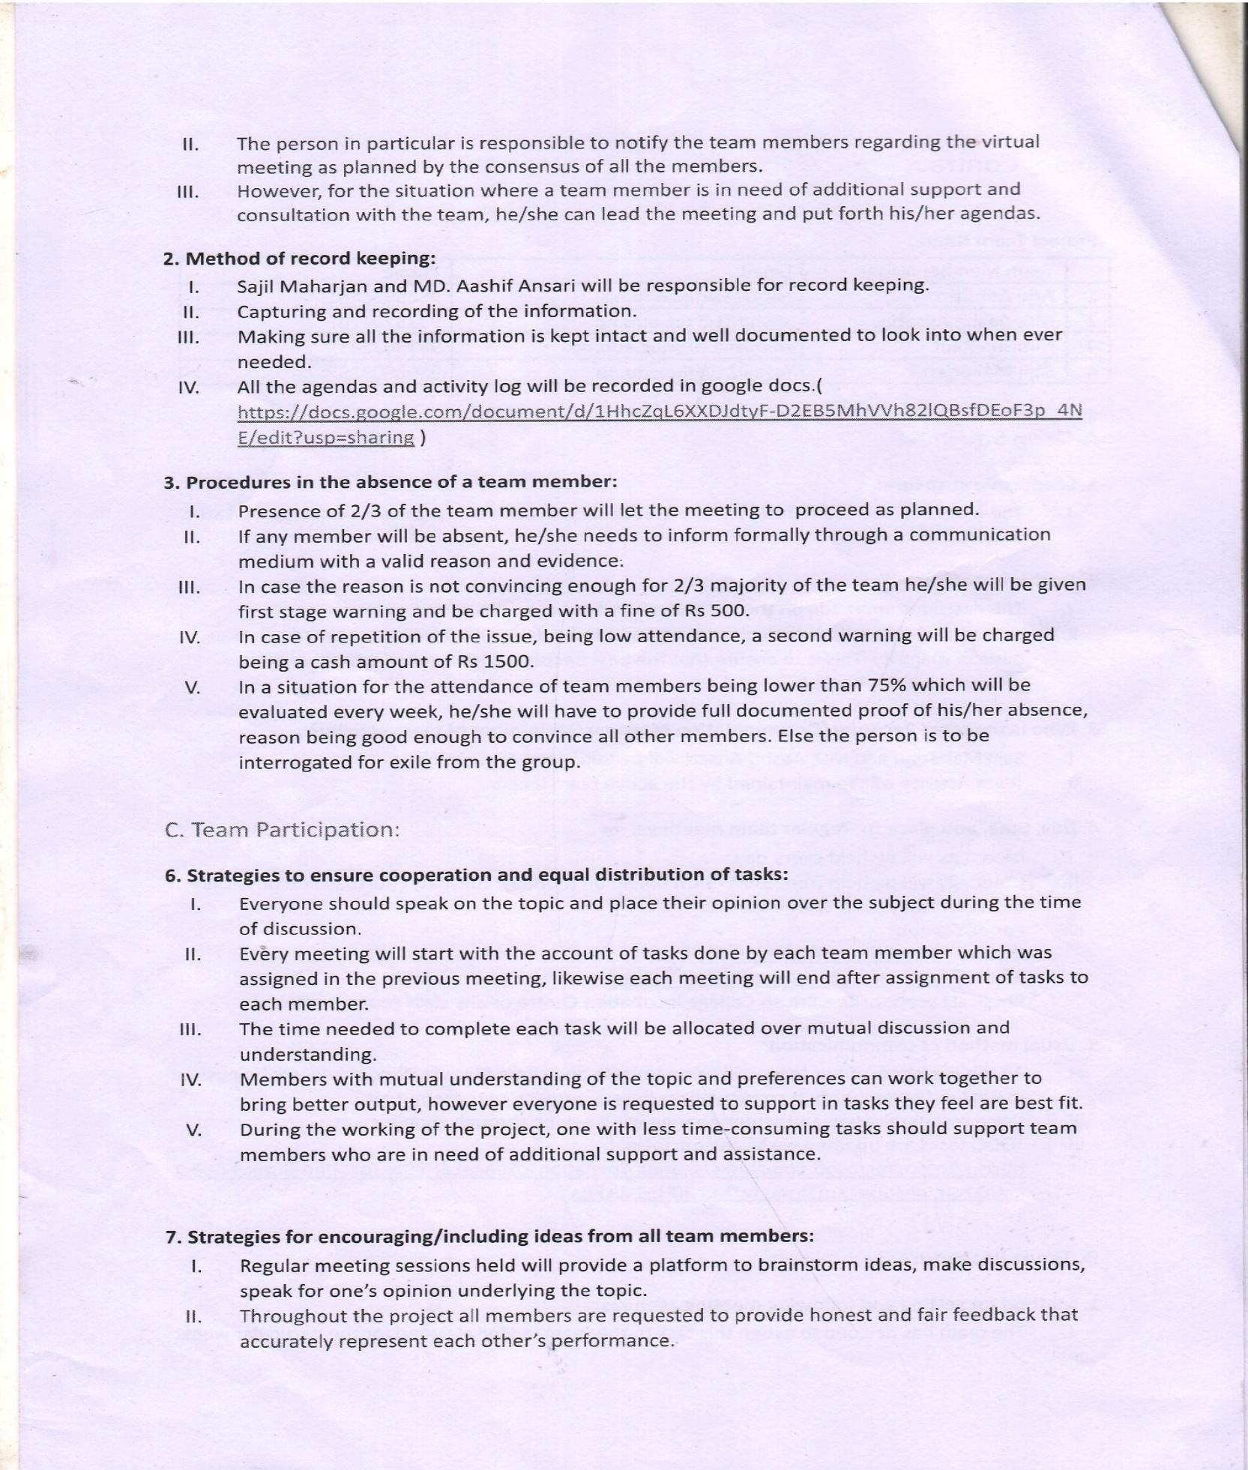

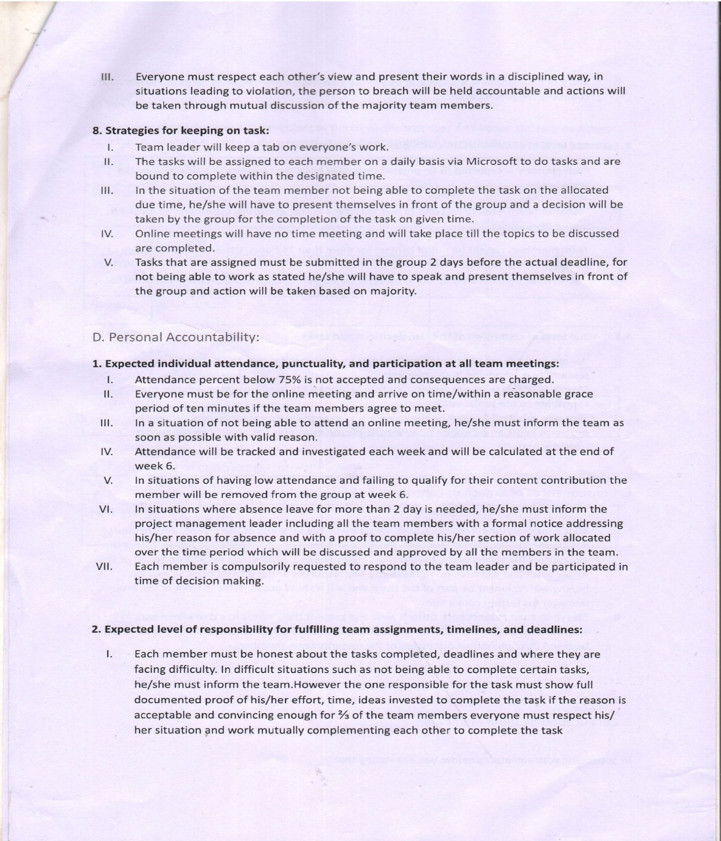

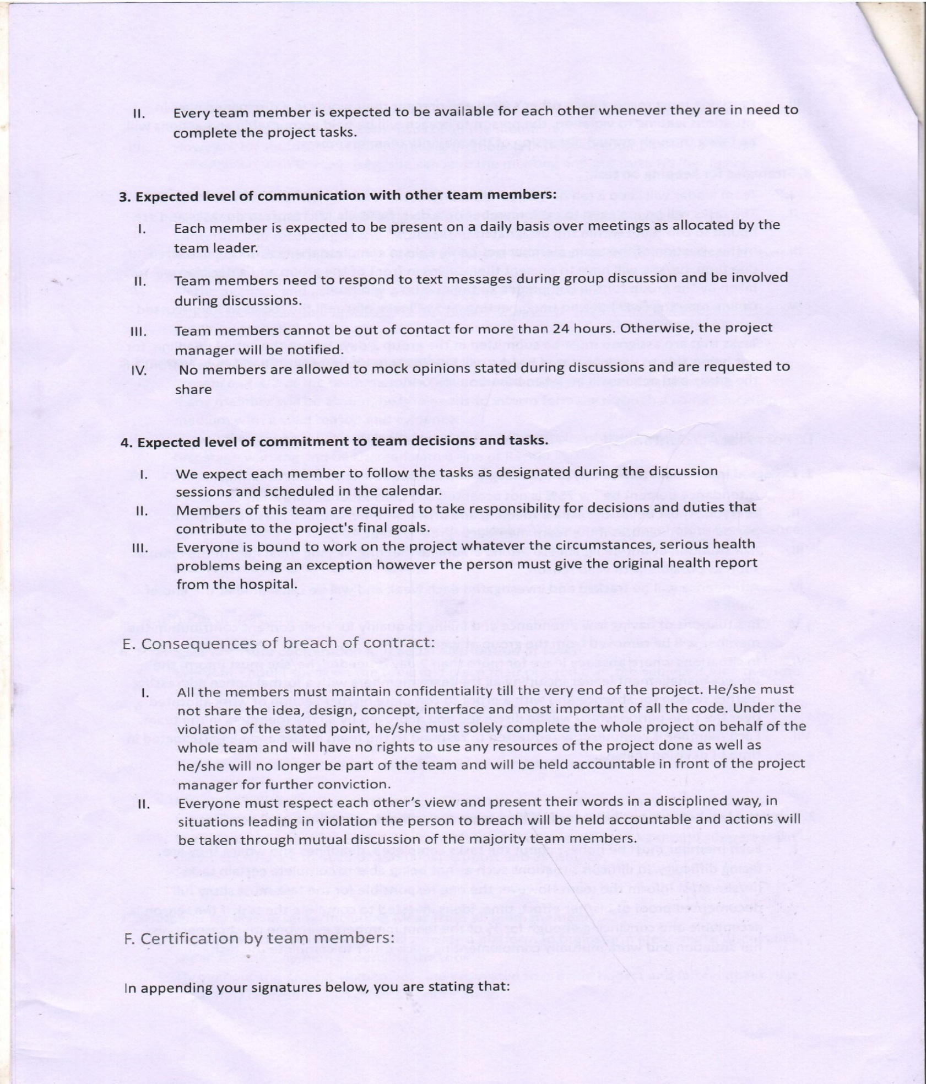

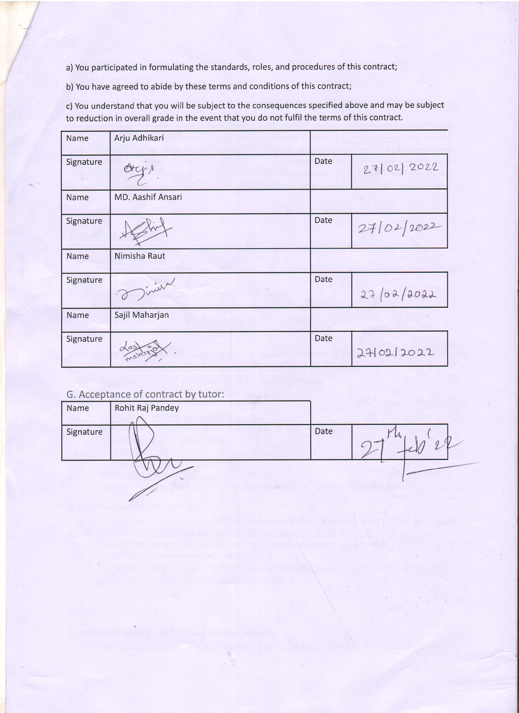

## Team Meetings

#### Meeting 1

|  |  |  |  |  |
| --- | --- | --- | --- | --- |
| Meeting Date | Agenda | Platform | Present | Absent |
| 25/02/2022 | Documentation for Project charter while reviewing case study. | [Meet - kfm-hfpf-zqt](https://meet.google.com/kfm-hfpf-zqt?pli=1&authuser=1) (Google Meet) | All | None |
| Terms and conditions for team contract. |
|  | | | | |

#### Meeting 2

|  |  |  |  |  |
| --- | --- | --- | --- | --- |
| Meeting Date | Agenda | Platform | Present | Absent |
| 27/02/2022 | Reviewing Team contract for finalization. | The British College, Room B4 | All | None |

#### Meeting 3

|  |  |  |  |  |
| --- | --- | --- | --- | --- |
| Meeting Date | Agenda | Platform | Present | Absent |
| 27/02/2022 | Backend research for managing cart and Wishlist. | [Meet - kfm-hfpf-zqt](https://meet.google.com/kfm-hfpf-zqt?pli=1&authuser=1) (Google Meet) | All | None |
|  | | | | |

#### Meeting 4

|  |  |  |  |  |
| --- | --- | --- | --- | --- |
| Meeting Date | Agenda | Platform | Present | Absent |
| 29/02/2022 | Discussion regarding tools needed for completing the project. | [Meet - kfm-hfpf-zqt](https://meet.google.com/kfm-hfpf-zqt?pli=1&authuser=1) (Google Meet) | Arju, Nimisha, Sajil | MD Aashif |
|  | | | | |

#### Meeting 5

|  |  |  |  |  |
| --- | --- | --- | --- | --- |
| Meeting Date | Agenda | Platform | Present | Absent |
| 03/03/2022 | Calculating average skill of team members. | [Meet - kfm-hfpf-zqt](https://meet.google.com/kfm-hfpf-zqt?pli=1&authuser=1) (Google Meet) | All | None |
|  | | | | |

#### Meeting 6

|  |  |  |  |  |
| --- | --- | --- | --- | --- |
| Meeting Date | Agenda | Platform | Present | Absent |
| 06/03/2022 | Learning Email verification during registration process. | [Meet - kfm-hfpf-zqt](https://meet.google.com/kfm-hfpf-zqt?pli=1&authuser=1) (Google Meet) | Arju, Nimisha, Sajil | MD Aashif |
|  | | | | |

#### Meeting 7

|  |  |  |  |  |
| --- | --- | --- | --- | --- |
| Meeting Date | Agenda | Platform | Present | Absent |
| 08/03/2022 | Front end design for Customer interface. | [Meet - kfm-hfpf-zqt](https://meet.google.com/kfm-hfpf-zqt?pli=1&authuser=1) (Google Meet) | All | None |
|  | | | | |

#### Meeting 8

|  |  |  |  |  |
| --- | --- | --- | --- | --- |
| Meeting Date | Agenda | Platform | Present | Absent |
| 09/03/2022 | Finalizing training requirement for each member to complete project. | [Meet - kfm-hfpf-zqt](https://meet.google.com/kfm-hfpf-zqt?pli=1&authuser=1) (Google Meet) | All | None |
|  | | | | |

#### Meeting 9

|  |  |  |  |  |
| --- | --- | --- | --- | --- |
| Meeting Date | Agenda | Platform | Present | Absent |
| 10/03/2022 | Wireframe for homepage, login and registration page. | [Meet - kfm-hfpf-zqt](https://meet.google.com/kfm-hfpf-zqt?pli=1&authuser=1) (Google Meet) | All | None |
|  | | | | |

#### Meeting 10

|  |  |  |  |  |
| --- | --- | --- | --- | --- |
| Meeting Date | Agenda | Platform | Present | Absent |
| 17/03/2022 | Working Time Discussion for MS-Project. | The British College, Room B5 | All | None |

#### Meeting 11

|  |  |  |  |  |
| --- | --- | --- | --- | --- |
| Meeting Date | Agenda | Platform | Present | Absent |
| 18/03/2022 | Task Sheet for Project Management. | [Meet - kfm-hfpf-zqt](https://meet.google.com/kfm-hfpf-zqt?pli=1&authuser=1) (Google Meet) | Arju, Nimisha, Sajil | MD Aashif |
|  | | | | |

#### Meeting 12

|  |  |  |  |  |
| --- | --- | --- | --- | --- |
| Meeting Date | Agenda | Platform | Present | Absent |
| 19/03/2022 | Use Case Diagram. | [Meet - kfm-hfpf-zqt](https://meet.google.com/kfm-hfpf-zqt?pli=1&authuser=1) (Google Meet) | All | None |
|  | | | | |

#### Meeting 13

|  |  |  |  |  |
| --- | --- | --- | --- | --- |
| Meeting Date | Agenda | Platform | Present | Absent |
| 21/03/2022 | Reviewing code for customer registration form validation. | [Meet - kfm-hfpf-zqt](https://meet.google.com/kfm-hfpf-zqt?pli=1&authuser=1) (Google Meet) | All | None |
| Reviewing design for homepage. |
|  | | | | |

#### Meeting 14

|  |  |  |  |  |
| --- | --- | --- | --- | --- |
| Meeting Date | Agenda | Platform | Present | Absent |
| 22/03/2022 | Wireframe finalization | [Meet - kfm-hfpf-zqt](https://meet.google.com/kfm-hfpf-zqt?pli=1&authuser=1) (Google Meet) | Arju, Nimisha, Sajil | MD Aashif |
|  | | | | |

#### Meeting 15

|  |  |  |  |  |
| --- | --- | --- | --- | --- |
| Meeting Date | Agenda | Platform | Present | Absent |
| 03/04/2022 | Login page development. | [Meet - kfm-hfpf-zqt](https://meet.google.com/kfm-hfpf-zqt?pli=1&authuser=1) (Google Meet) | Arju, Nimisha, Sajil | MD Aashif |
|  | | | | |

#### Meeting 15

|  |  |  |  |  |
| --- | --- | --- | --- | --- |
| Meeting Date | Agenda | Platform | Present | Absent |
| 08/04/2022 | Reviewing About Us Page | https://meet.google.com/gcs-ejgc-zvr (Google Meet) | All | None |
|  | | | | |

# Planning Phase

## Skill Audit

### Team Skill Audit

|  |  |  |  |  |  |  |  |
| --- | --- | --- | --- | --- | --- | --- | --- |
| **Team Skills Audit (Phoenix Mart)** | | | | | | | |
|  |
|  |  |  |  |  |  | **Skill Level: 1 (No Knowledge) - 5 (Competent)** | |  |
|  | **Date Reviewed: 03/03/2022** | | **Completed By: Phoenix Mart Team** | **Version 1.0** |  |  |
|  |  |  |  |  |  |  |
| NO# | Skill Required | Skill Level (1- 5) | Training Action | Training Objective | Time (hrs.) | Training Completion Deadline | Training for? |  |
| 1 | PHP Programming | 2.75 | Learn via different online resources available on the internet. | To become more efficient and implement it for the completion of back-end of the project. | 14.5 | 3/19/2022 | All Team Members |  |
| 2 | HTML | 3.375 | Explore W3School and learn through execution. | To advance the skills required for creating a website, implementing all the functionalities provided by the language. | 10.75 | 3/10/2022 | Arju Adhikari, MD Aashif Ansari |  |
| 3 | CSS | 3.375 | Watch recordings and lecture slides made available from level 3 and 4. | Using it to display the webpages using different styles and making it much more presentable. | 10.75 | 3/12/2022 | Arju Adhikari, MD Aashif Ansari |  |
| 4 | JavaScript | 2.25 | Explore different JavaTutorialPoint sites and excel the validation requirements. | Learn functionalities necessary for advancing the basic and to define behavior of webpage. | 13 | 3/19/2022 | All Team Members |  |
| 5 | Moqup | 4 | Frequent use of the tools provided for creating wireframe. | To create a basic blueprint for the webpage. | 2 |  |  |  |
| 6 | QSEE | 4 | Going through notes from previous semester and exploring diagram tools more. | For designing diagram such as UML and ERD needed for developing ecommerce system. | 2.75 |  |  |  |
| 7 | Database Oracle | 3.13 | Watch YouTube videos related to subject matter and follow up resources. | For designing a efficient data storage and retrieval system required for building a ecommerce website. | 13 | 3/24/2022 | All Team Members |  |
| 8 | Photoshop | 3.5 | Follow up online resources such as videos and samples for designing. | To be efficient in the tools and to make its use. | 5 | 3/6/2022 | Nimisha Raut, Sajil Maharjan |  |
| 9 | Illustrator | 3.25 | Grasp ideas and skills through tutors available online for free. | To create logo and vector graphics to use in the webpage. | 4.25 | 3/6/2022 | Nimisha Raut, Sajil Maharjan |  |
| 10 | Mila note | 3 | Watch through tutorial video to learn the basic interface. | Make the optimum utilization of the facilities provided by the software. | 4 | 3/7/2022 | MD Aashif Ansari, Nimisha Raut, Sajil Maharjan |  |
| 11 | Visual Studio Code | 3.25 | Look up for guidelines available on efficient use of the IDE. | For making maximum use of tools facilitated by the software while writing codes. | 2 |  |  |  |
| 12 | Awesome Font | 3.75 | Reviewing the website and practice to make use of the resources. | Include wide ranges of icons in the website to make it much more presentable. | 2.25 | 3/6/2022 | Nimisha Raut, Sajil Maharjan |  |
| 13 | GitHub | 3 | Watch videos for guidance and use the interface more frequently. | For organized and managed sharing and storage of codes among the teammates. | 3 | 3/16/2022 | Arju Adhikari, Sajil Maharjhan |  |
| 14 | Bootstrap | 2.88 | Surf online course and explore the bootstrap 5 website deeply. | For the framework's compatibility with all major browser versions and platforms and has a superior grid system along with better styling in less time. | 5 | 3/17/2022 | Nimisha Raut, Sajil Maharjan |  |
| 15 | Sandbox | 1.25 | Watch tutorial videos and take guidelines from the internet. | Make it use to create a PayPal interface and explore additional ways to use it. | 5.5 | 3/29/2022 | All Team Members |  |
| 16 | XAMPP | 3.125 | Revise instructions provided previously by the tutor. | To local host and check the working of the webpage. | 2.75 |  |  |  |
| 17 | UI/UX Design | 3.125 | Practical approach to learn and advance the basics by analyzing and studying different resources available on the internet. | To develop an outline for the development of an ecommerce site. | 4.75 | 3/8/2022 | Nimisha Raut, Sajil Maharjhan |  |
| 18 | Discord | 2.875 | Watch YouTube videos and follow along. | To communicate with team members and regular share of files. | 1.25 | 3/5/2022 | Arju Adhikari, Nimisha Raut |  |
| 19 | MS Word | 4 | Search for guideline articles on internet when required. | Make it use throughout building of the project. | 1.5 |  |  |  |
| 20 | MS Excel | 2 | Surf the YouTube tutorials and learn the basic tools. | For effective and efficient store of the document related to the project. | 2.25 | 3/6/2022 | Arju Adhikari, MD Aashif Ansari |  |
| 21 | MS Project | 1 | Learn from the very basic through self-exploration as well as lecture guidance. | To manage and control the operation of tasks for directing a project. | 7.5 | 3/28/2022 | All Team Members |  |
| 22 | PowerPoint | 3.375 | Follow guidelines and explore techniques to create a presentation. | To make presentation slides when required. | 1.75 |  |  |  |
| 23 | Adobe Premium Pro | 2 | Go through tutorial videos and be familiar with the software tools. | To edit videos and adjust the video sizes to place in the webpage. | 4.75 | 3/16/2022 | MD Aashif Ansari, Nimisha Raut, Sajil Maharjan |  |

### Individual Skill Audit

|  |  |  |  |  |  |  |  |
| --- | --- | --- | --- | --- | --- | --- | --- |
| **Individual Skills Audit (Nimisha Raut)** | | | | | | | |
|  |
|  |  |  |  |  |  | **Skill Level: 1 (No Knowledge) - 5 (Competent)** | |  |
|  | **Date Reviewed: 03/03/2022** | | **Completed By: Nimisha Raut** | **Version 1.0** |  |  |
|  |  |  |  |  |  |  |
| NO# | Skill Required | Skill Level (1- 5) | Training Action | Training Objective | Time (hrs.) | Training Completion Deadline | Training for? |  |
| 1 | PHP Programming | 3.5 | Go through W3School resources and other online articles, follow along YouTube tutorials especially ecommerce sites. | Be more comfortable with PHP implementation to add more functionality. | 16 | 3/19/2022 | Nimisha Raut |  |
| 2 | HTML | 3.5 | Go over old projects and browse through online articles. Do revision on syntax from W3School. | For developing structure of webpages and embed PHP code properly. | 5 | 3/10/2022 | Nimisha Raut |  |
| 3 | CSS | 3 | Revise from W3School and go through old projects. | To style and modify design of webpages and use of media query. | 6 | 3/12/2022 | Nimisha Raut |  |
| 4 | JavaScript | 2.5 | Go through online articles, watch video tutorials and revise old notes. | Enhance functionality of website to produce interactive webpages conduct and client-side validation. | 10 | 3/19/2022 | Nimisha Raut |  |
| 5 | Moqup | 4 | Visit website to familiarize with the interface for creating wireframe and look into older wireframes. | Make wireframe to show framework of the webpage. | 1 |  | Nimisha Raut |  |
| 6 | QSEE | 4 | Go through old slides and projects. | Produce ERD and Use Case Diagram for visual representation of system. | 1 |  | Nimisha Raut |  |
| 7 | Database Oracle | 3.5 | Research more articles especially on effective ways of storing data, YouTube tutorials and revisit old assignments. | To develop efficient database to store, to retrieve any data needed for the system and more features of page designer. | 16 | 3/24/2022 | Nimisha Raut |  |
| 8 | Photoshop | 3.5 | Browse through YouTube tutorials, revise notes and resources from previous semester. | Learn image manipulation. Also experimenting design before code implementation. | 4 | 3/6/2022 | Nimisha Raut |  |
| 9 | Illustrator | 2.5 | Browse through YouTube tutorials while practicing the software tools. | Learn designing of vector images. | 3 | 3/6/2022 | Nimisha Raut |  |
| 10 | Mila note | 2 | Check out guideline for help, surf and use the website features more. | To produce organized idea board for visual representation. | 2 | 3/7/2022 | Nimisha Raut |  |
| 11 | Visual Studio Code | 3.5 | Follow along tutorials available on network. | For more efficient and effective way to write code by maximum utilization of developer tools. | 1 |  | Nimisha Raut |  |
| 12 | Awesome Font | 3.5 | Learn through YouTube tutorial. | For using built in icons in website. | 1 | 3/6/2022 | Nimisha Raut |  |
| 13 | GitHub | 3.5 | Watch guideline videos and surf the interface. | For collaborating with teammates to store code and materials while tracking the changes in code. | 2 | 3/16/2022 | Nimisha Raut |  |
| 14 | Bootstrap | 2.5 | Go through online code examples and practice code manipulation. | To design website framework being time efficient. | 2 | 3/17/2022 | Nimisha Raut |  |
| 15 | Sandbox | 2 | Go through video tutorials and examples available on internet. | Learn to implement virtual testing system for PayPal. | 4 | 3/29/2022 | Nimisha Raut |  |
| 16 | XAMPP | 3.5 | Watch guideline tutorials. | To create local host environment for testing website code on computer. | 1 |  | Nimisha Raut |  |
| 17 | UI/UX Design | 2.5 | Surf through examples as well as go through articles on internet. | Learn the principles that leads for efficient interface. | 6 | 3/8/2022 | Nimisha Raut |  |
| 18 | Discord | 2.5 | Check YouTube tutorials when needed or ask for assistance. | For maintaining communication between teammates and instant file sharing. | 1 | 3/5/2022 | Nimisha Raut |  |
| 19 | MS Word | 4 | Check for guideline when necessary. | For efficient documentation of project files. | 1 |  | Nimisha Raut |  |
| 20 | MS Excel | 2 | Go through YouTube tutorials and online search for guidelines. | Store data and records in organized format. | 2 | 3/6/2022 | Nimisha Raut |  |
| 21 | MS Project | 1 | Watch videos and guideline provided on Orbund to understand the tools needed for management. | To learn about managing projects through creation of Gantt chart, timeline, calendar. | 10 | 3/28/2022 | Nimisha Raut |  |
| 22 | PowerPoint | 3 | Check for online guidelines when necessary. | For making presentation slides utilizing maximum features provided by the software. | 1 |  | Nimisha Raut |  |
| 23 | Adobe Premium Pro | 1 | Follow along YouTube tutorials and get familiar with the tools and interface. | For editing videos to be embedded on the website. | 8 | 3/16/2022 | Nimisha Raut |  |

## Project Management (MS Project)

### Gantt Chart

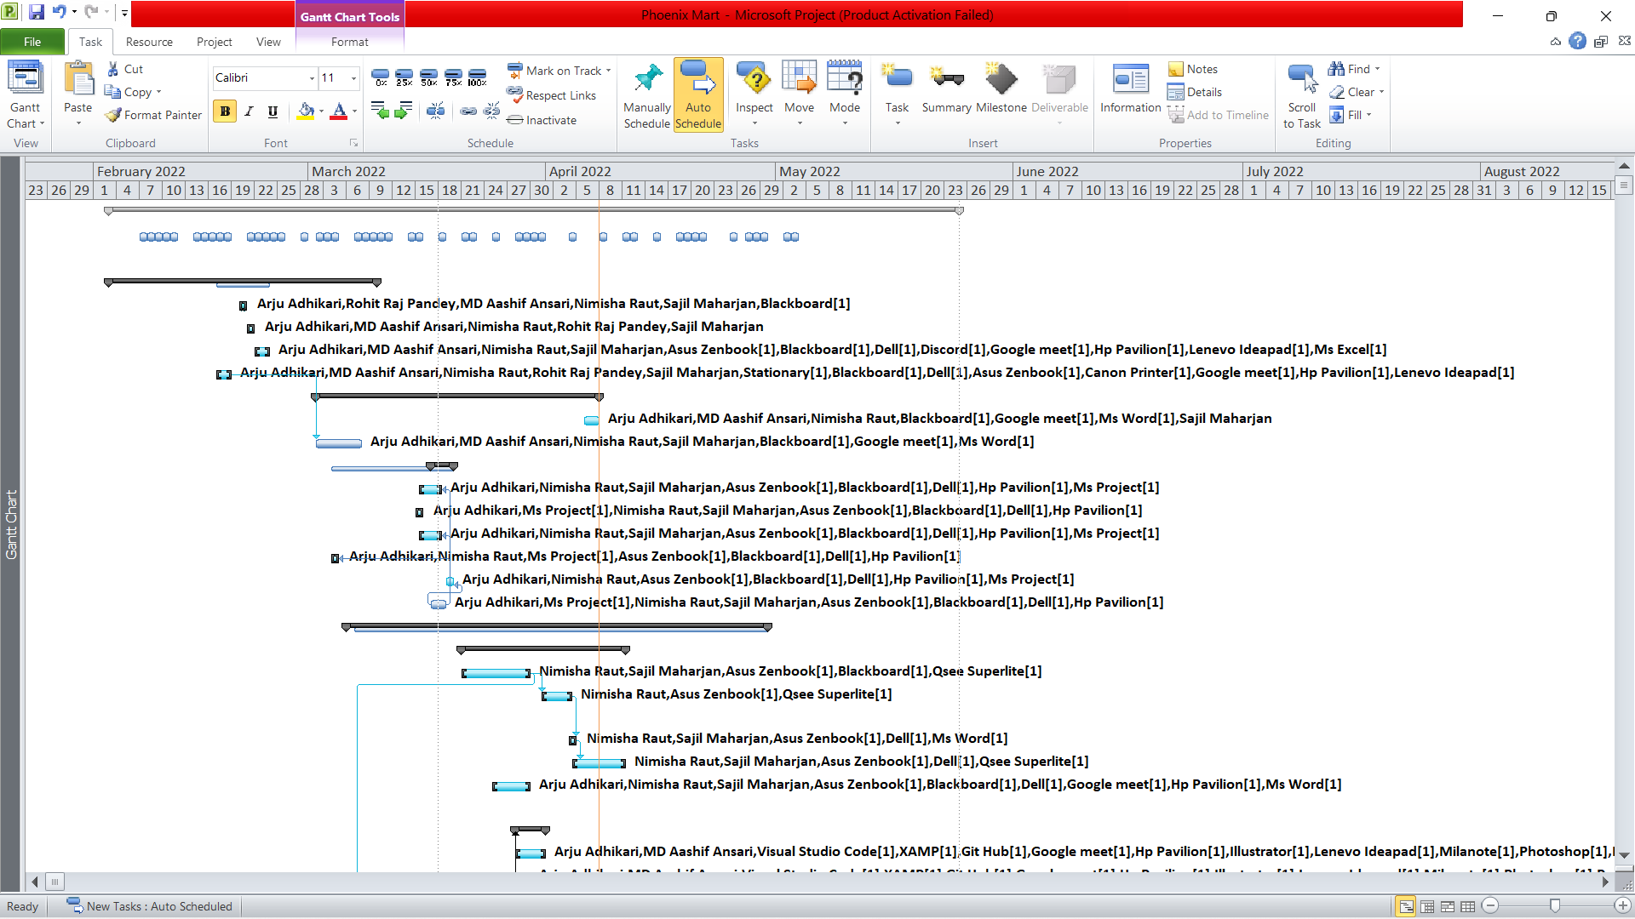

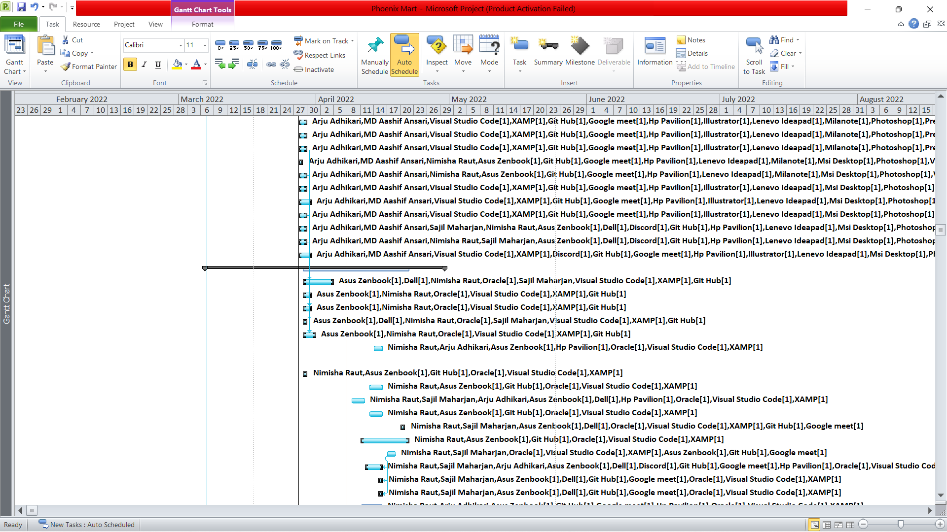

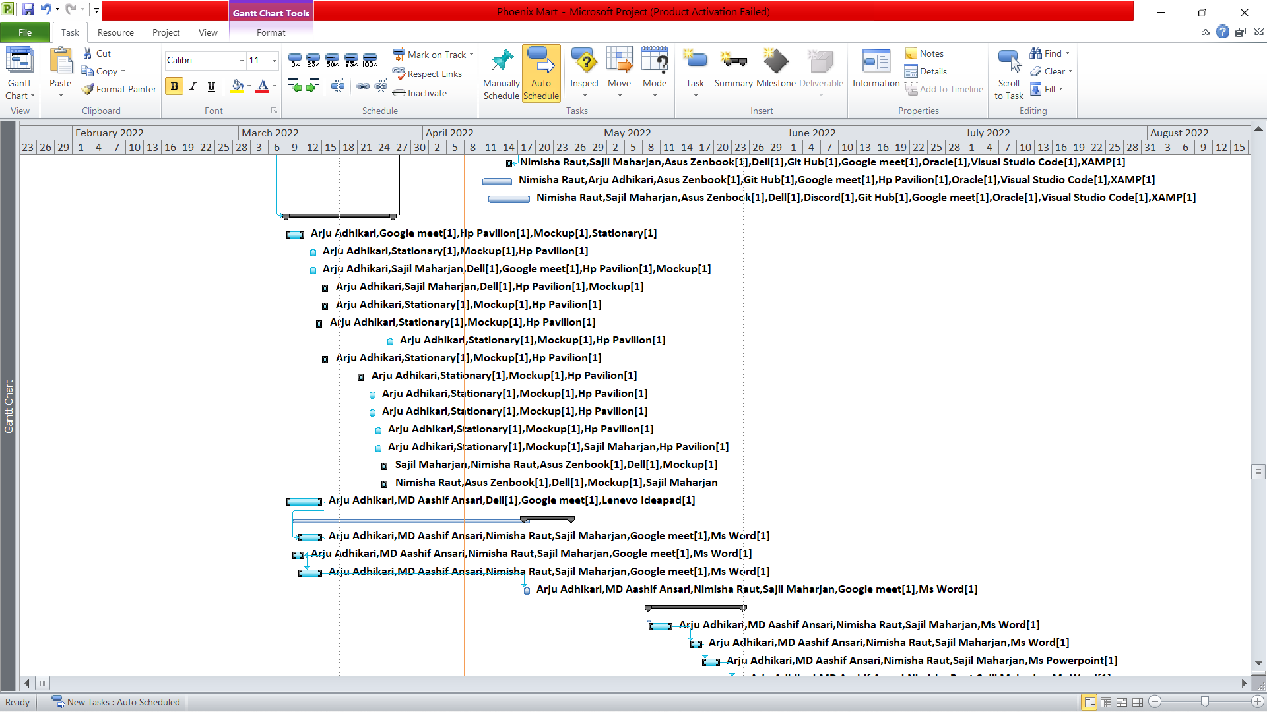

### Timeline

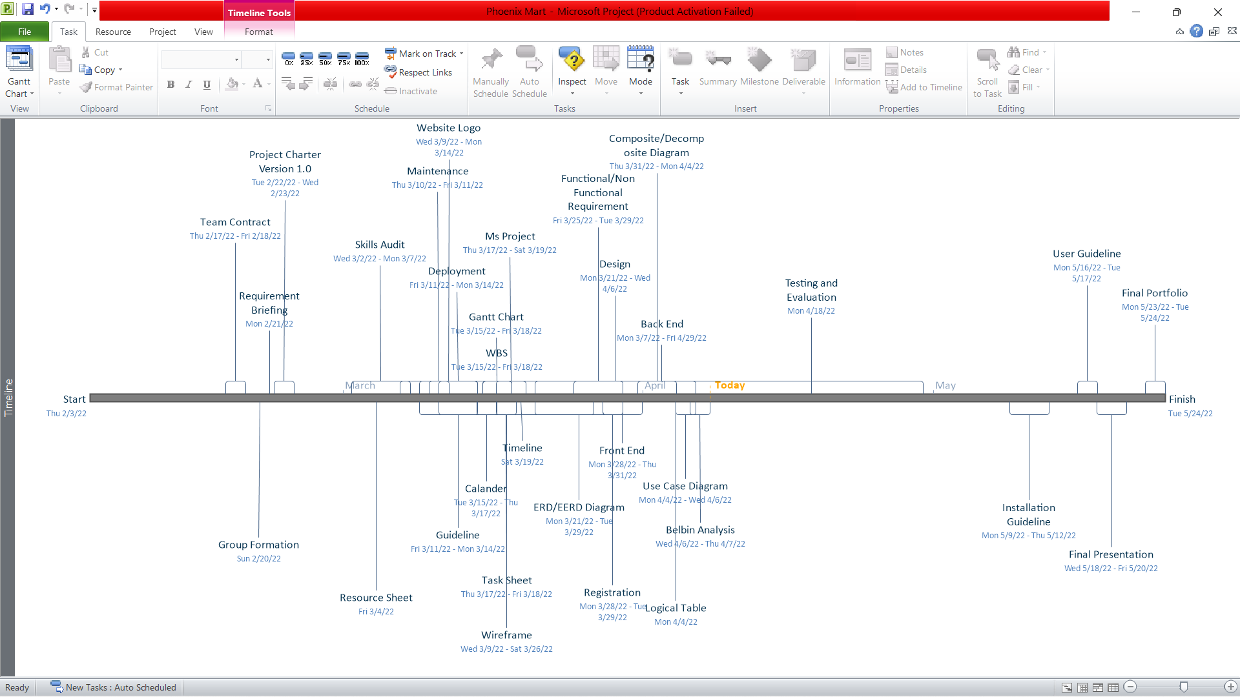

### Task Sheet

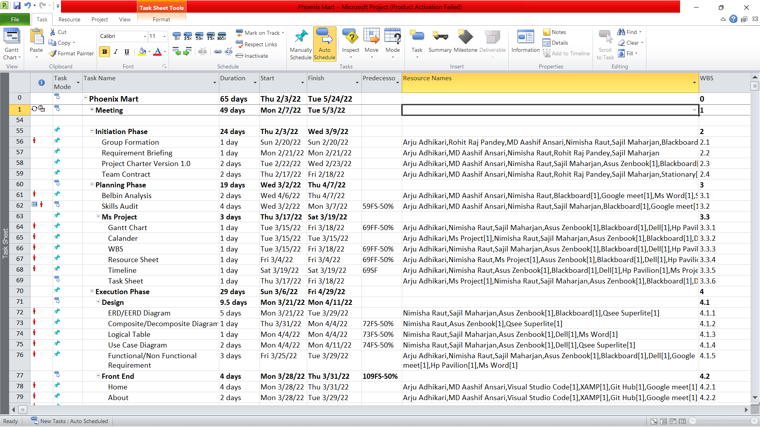

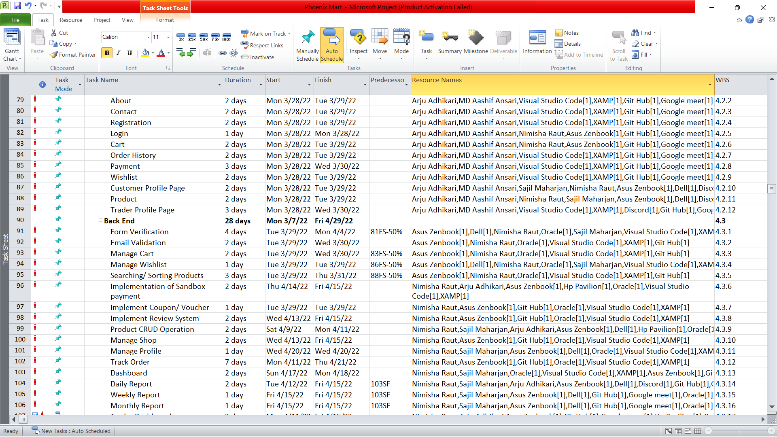

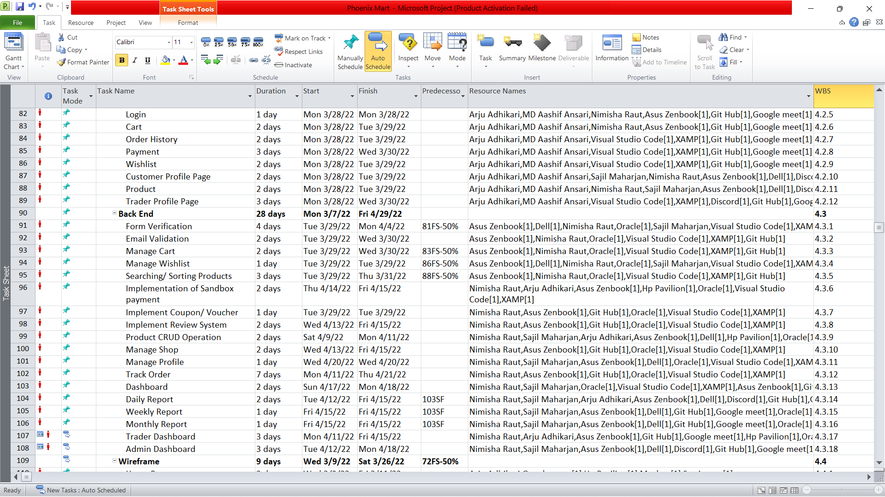

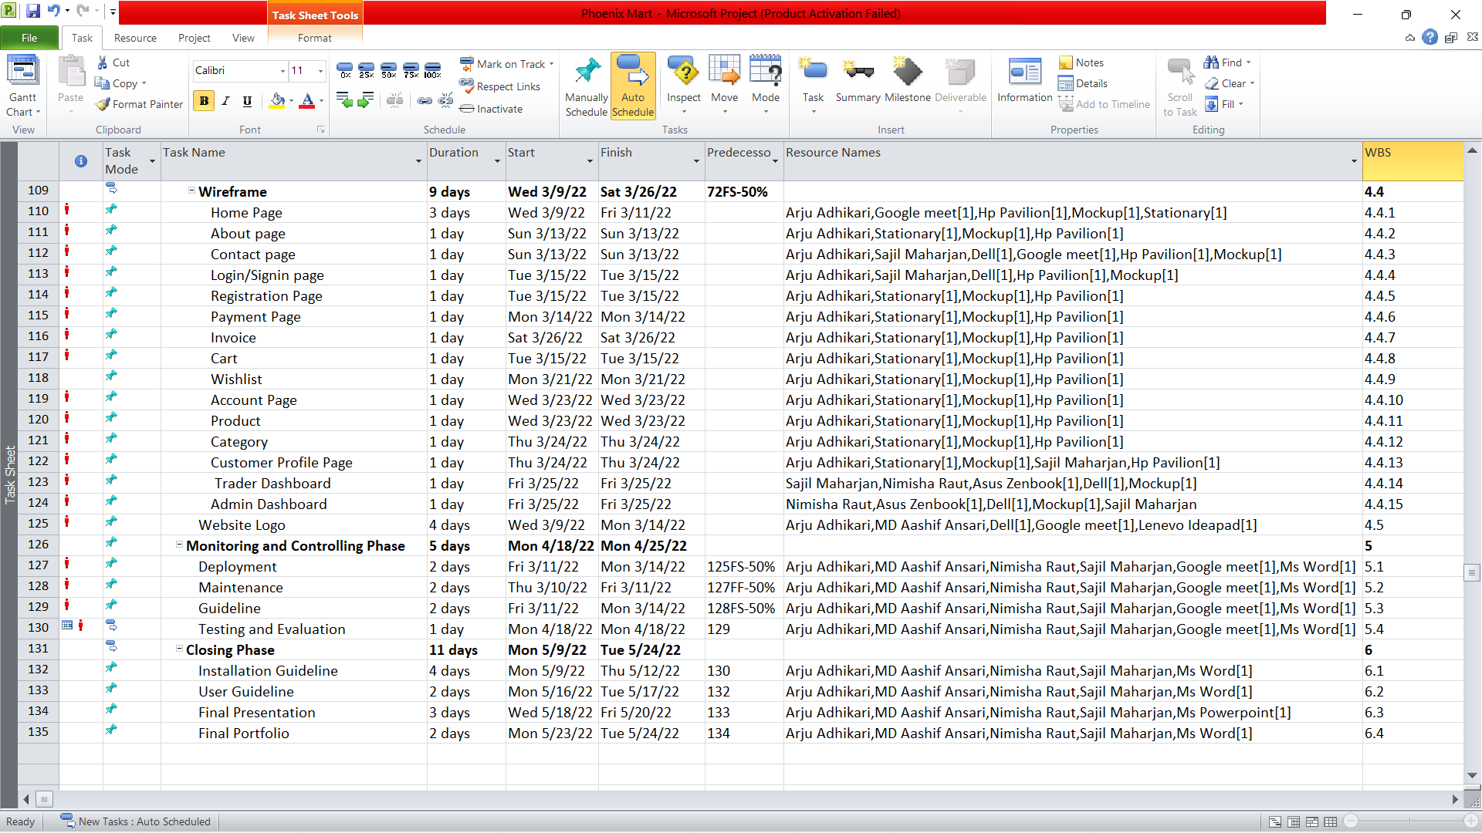

### Calendar

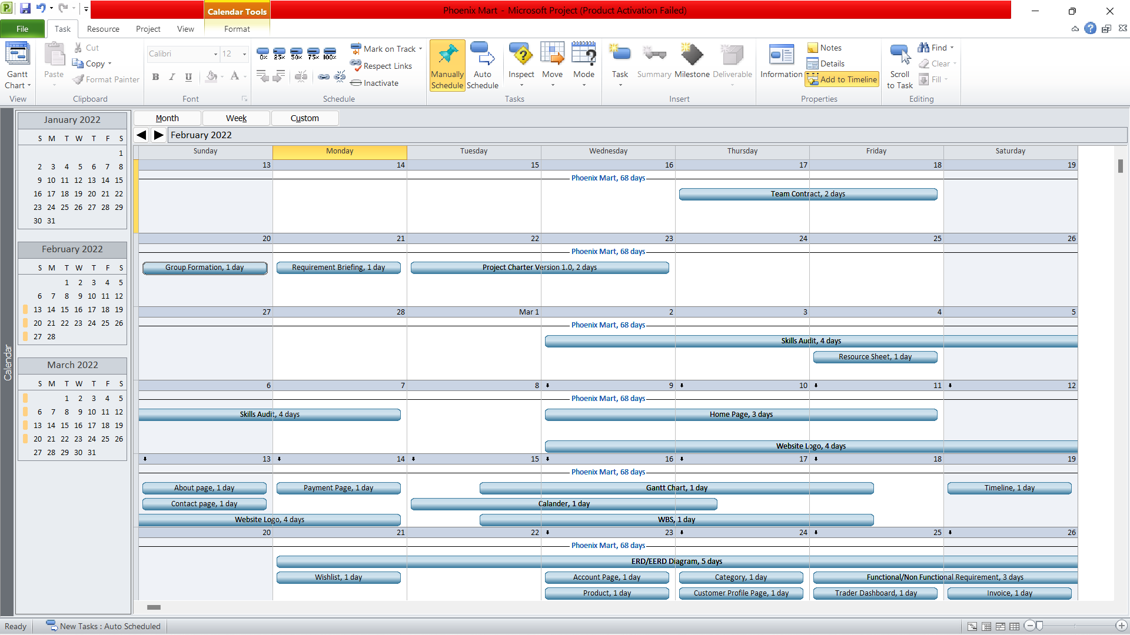

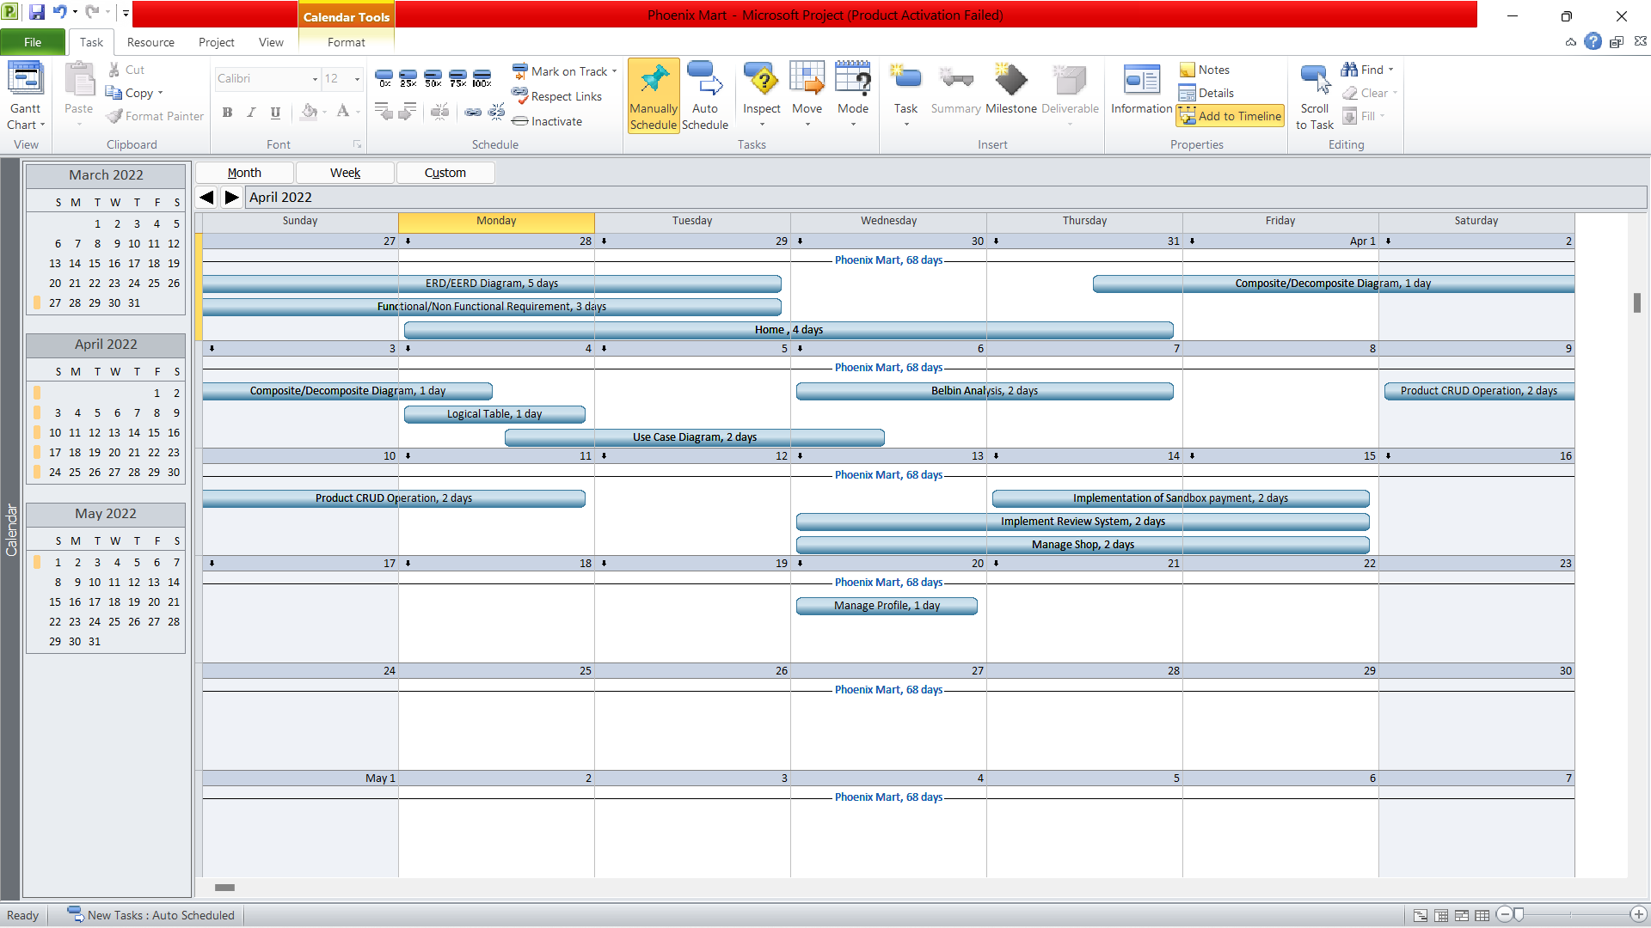

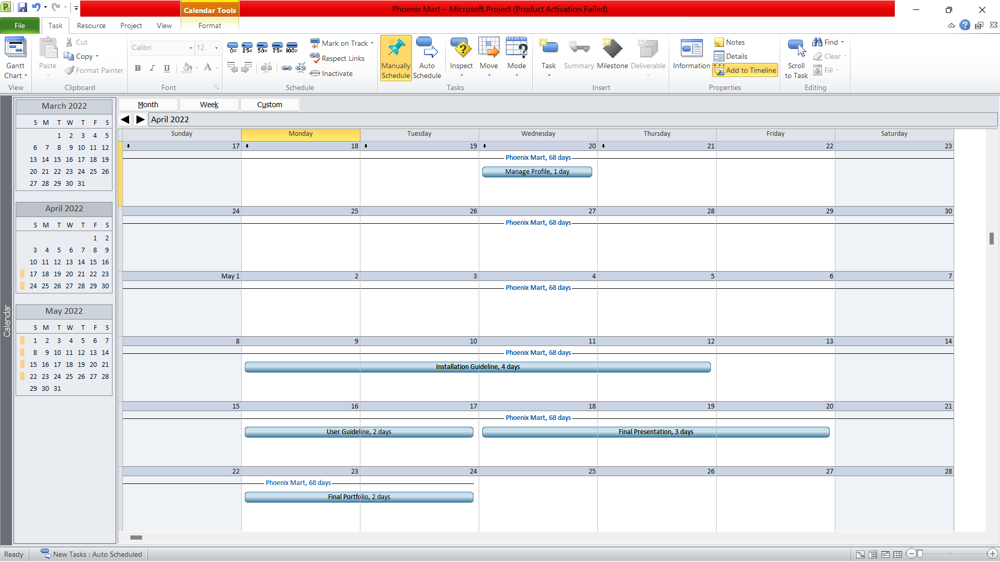

### Resource Sheet

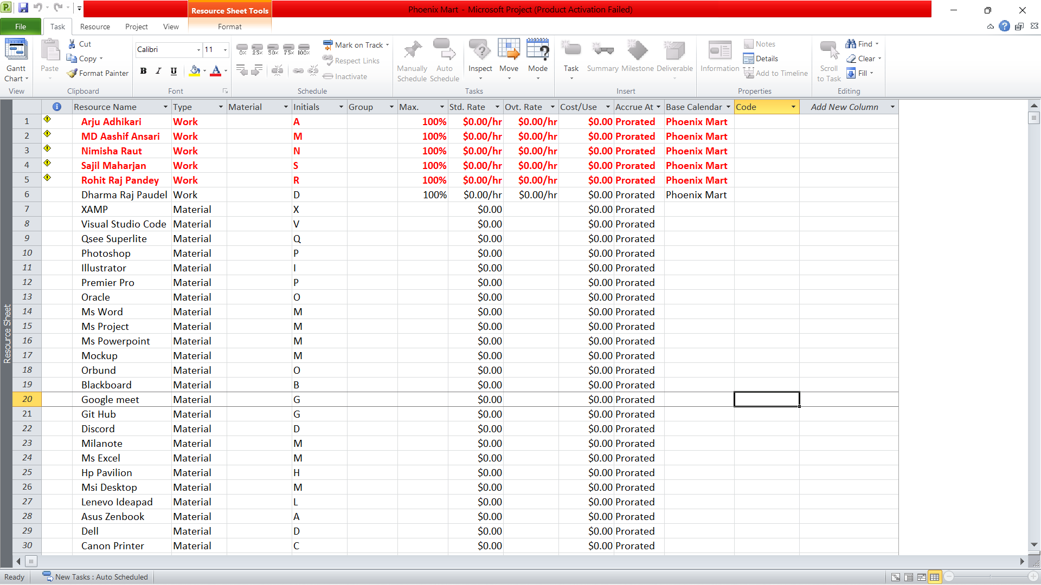

### Change Working Time

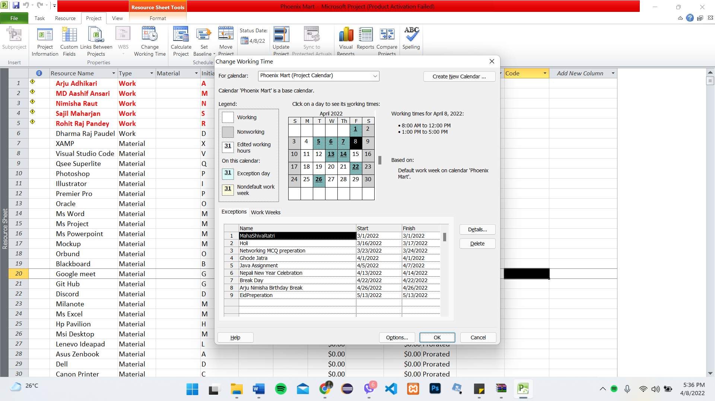

### **Communication Tool Used**

### GitHub

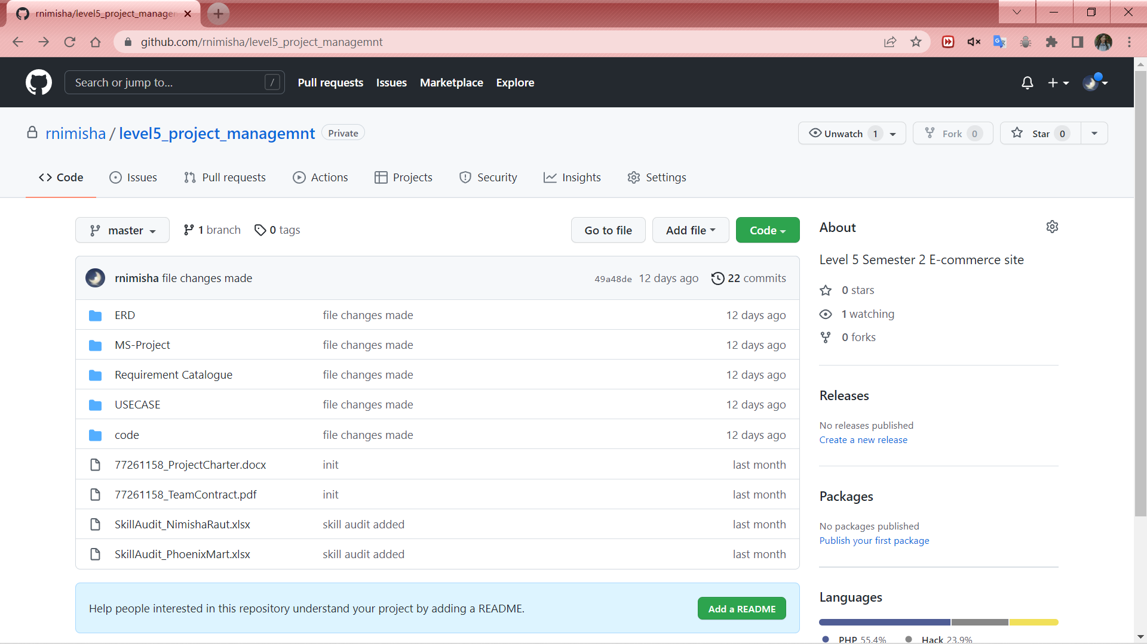

### Discord

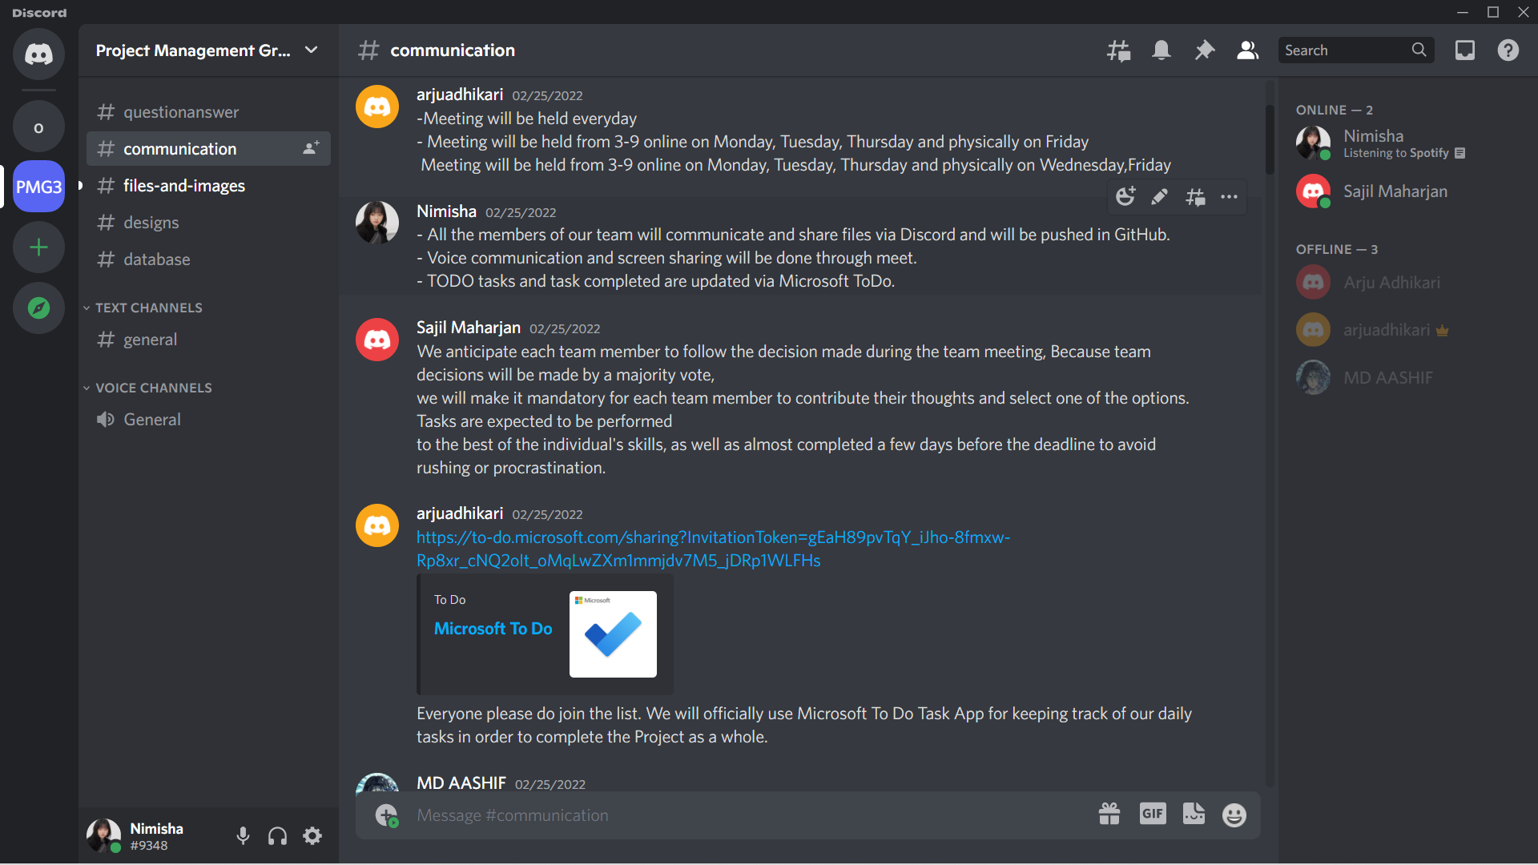

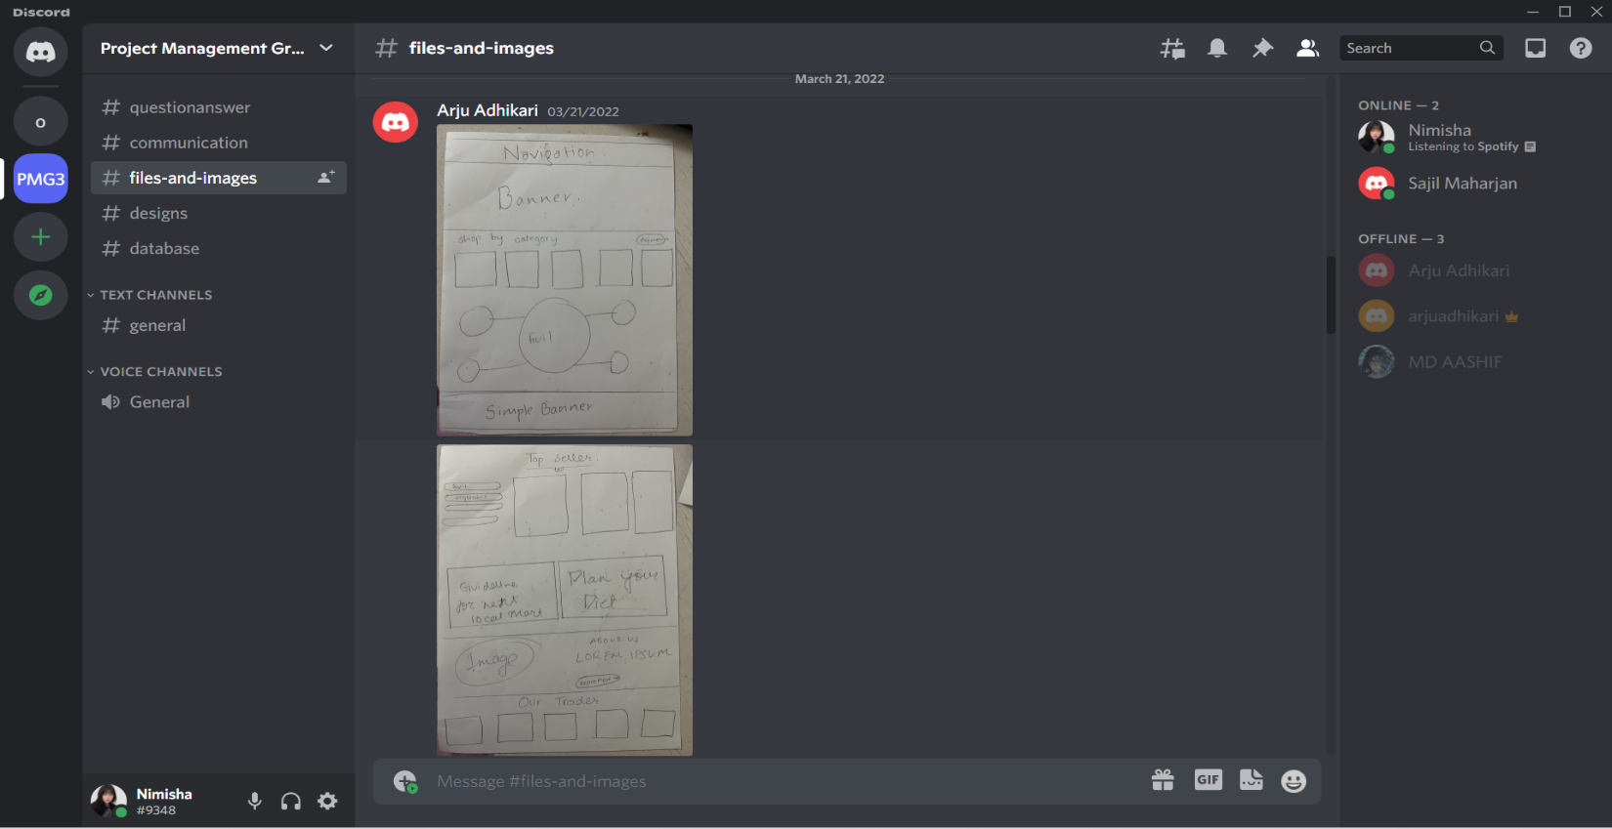

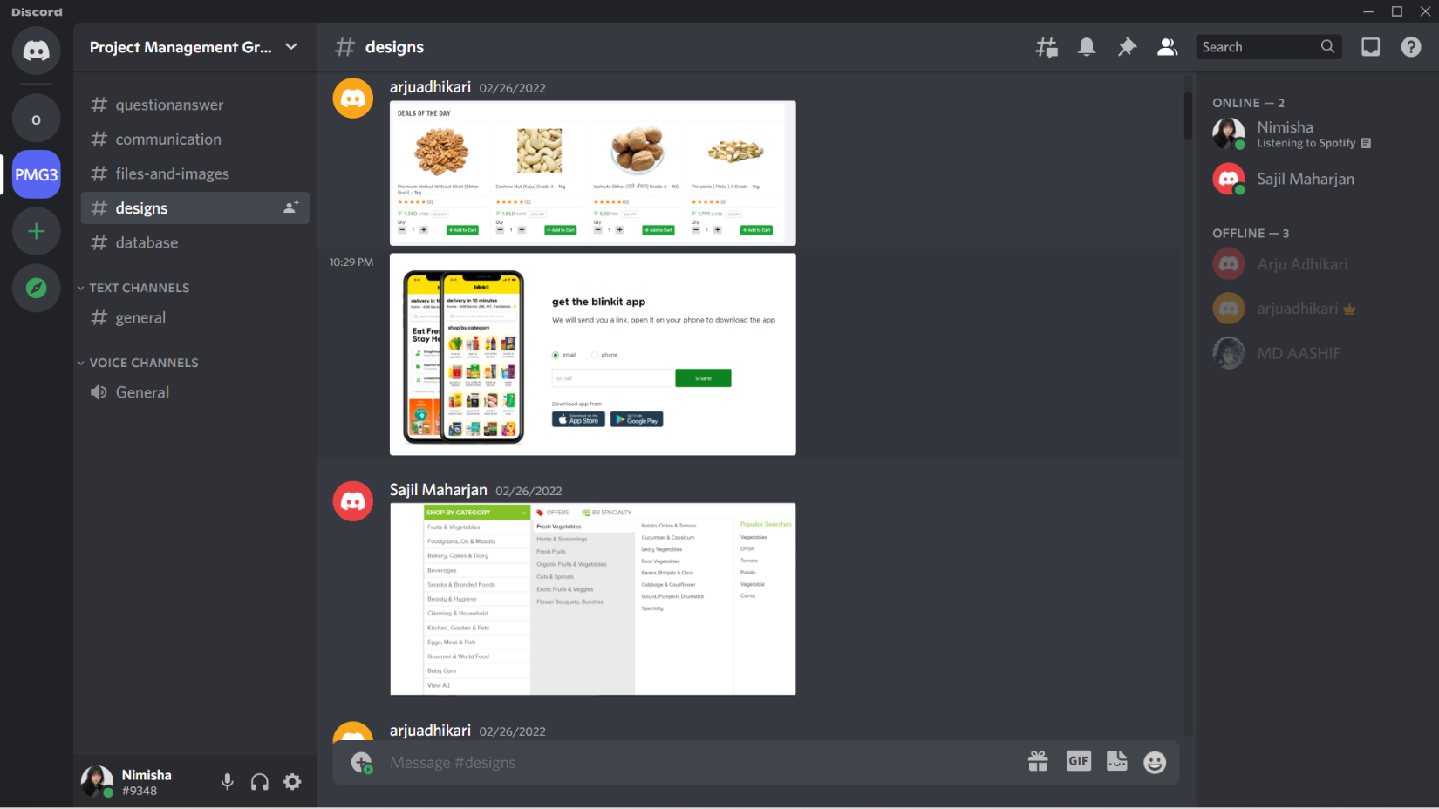

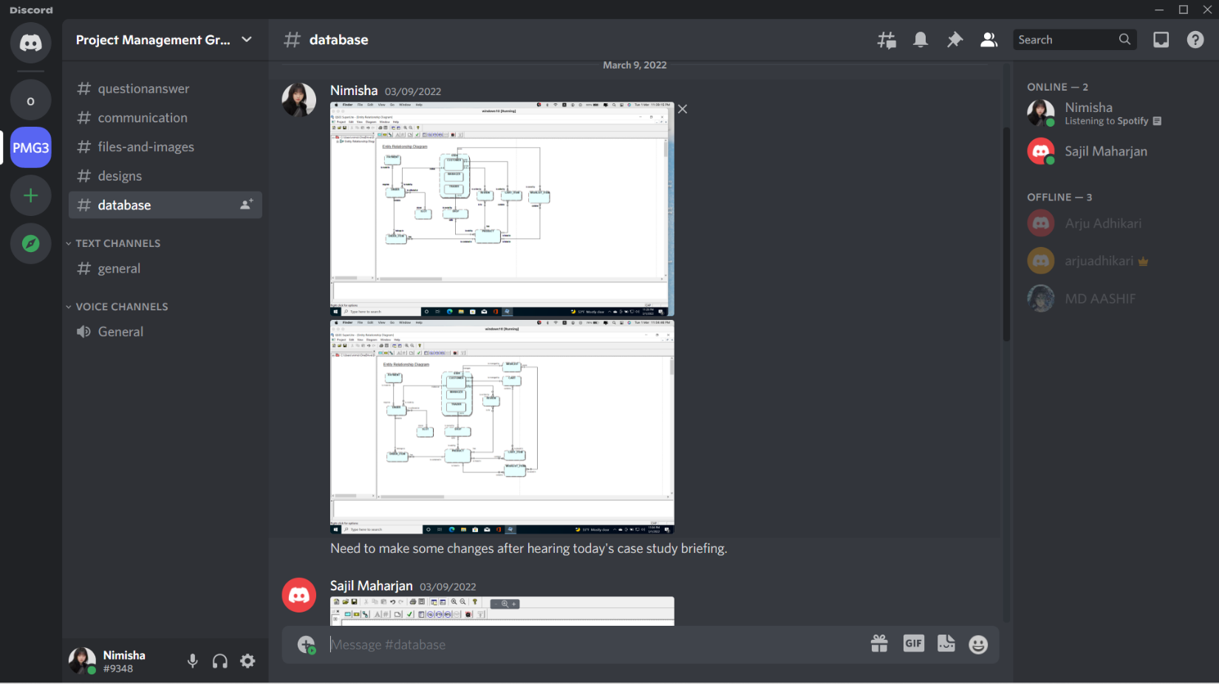

### Google Meet

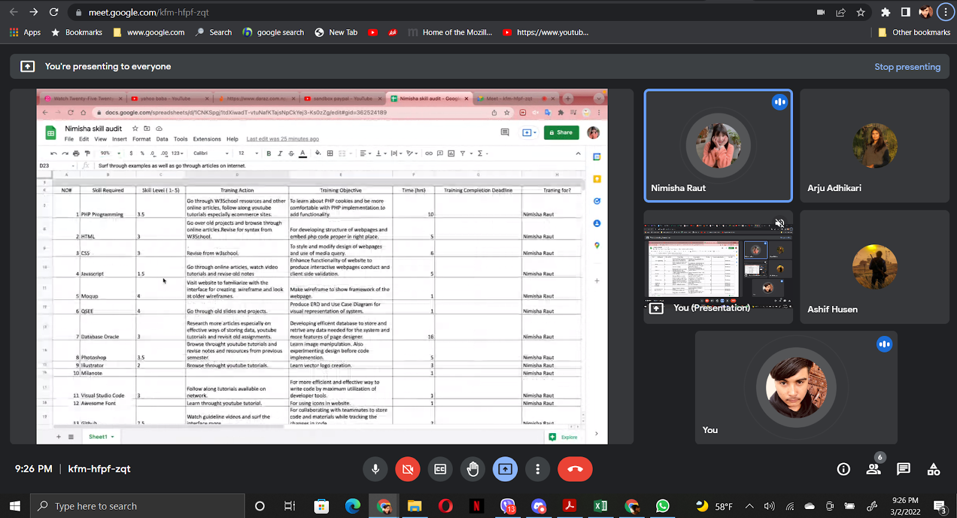

# Execution Phase

## Entity Relationship Diagram

### EERD



### ERD



### Final Composite/De-composite



### Logical Table

1. **USER** (**USER_ID**, NAME, EMAIL, PASSWORD, CONTACT, ADDDRESS, USER_ROLE, ACTIVE_STATUS, TOKEN, PROFILE_PIC, DOB)
2. **SHOP** (**SHOP_ID**, SHOP_NAME, REGISTRATION_ID, REGISTERED_DATE, ACTIVE_STATUS, SHOPLOGO, *USER_ID*)
3. **PRODUCT_CATEGORY** (**CATEGORY_ID**, CATEGORY_NAME, CATEGORY_IMAGE)
4. **DISCOUNT** (**DISCOUNT_ID**, DISCOUNT_NAME, DISCOUNT_RATE, START_DATE, EXPIRY_DATE)
5. **PRODUCT** (**PRODUCT_ID**, PRODUCT_NAME, DESCRIPTION, STOCK_QUANTITY, PRICE, PRICING_UNIT, MIN_ORDER, MAX_ORDER, ALLERGY_INFO, DISABLE, *SHOP_ID, DISCOUNT_ID, CATEGORY_ID*)
6. **PRODUCT_IMAGE** (**IMAGE_ID**, IMAGE_DETAIL, *PRODUCT_ID*)
7. **REVIEW** (**REVIEW_ID**, COMMENT, STAR_RATING, REVIEW_DATE, *USER_ID, PRODUCT_ID)*
8. **CART_ITEM** (**CART_ITEM_ID**, QUANTITY, *USER_ID, PRODUCT_ID)*
9. **WISHLIST_ITEM_ID** (**WISHLIST_ITEM_ID**, *USER_ID, PRODUCT_ID)*
10. **REPORT** (**REPORT_ID**, REPORT_DETAIL, *USER_ID, PRODUCT_ID)*
11. **SLOT** (**SLOT_ID**, SLOT_DAY, TIME_RANGE)
12. **PAYMENT** (**PAYMENT_ID**, PAYMENT_METHOD, ACCOUNT_ID, PAYMENT_TIME)
13. **COUPON** (**COUPON_ID**, COUPON_CODE, NUMBER_OF_USE, DISCOUNT_RATE, SYMBOL, DESCRIPTION, START_DATE, EXPIRY_DATE)
14. **ORDER (ORDER_ID**, ORDER_DATE, ORDER_STATUS, *USER_ID, PAYMENT_ID, SLOT_ID, COUPON_ID*)
15. **ORDER_COUPON (ORD_COUPON_ID**, *COUPON_ID, ORDER_ID)*
16. **ORDER_ITEM** (**ORDER_ITEM_ID**, ITEM_QUANTITY, UNIT_PRICE, DISCOUNT, *ORDER_ID, PRODUCT_ID*)

## Use Case Diagram

### Overview Use Case Diagram



### Customer Overview Use Case Diagram



### Trader Overview Use Case Diagram



### Admin Overview Use Case Diagram



## Requirement Catalogue

### Functional Requirement

#### A: Product

|  |  |  |
| --- | --- | --- |
| **Requirement ID** | **Description** | **MoSCoW** |
| **A1** | **All products need details.** |  |
| A1-01 | Each product is assigned with unique identifier. | M |
| A1-02 | Product should be associated with individual trader. | M |
| A1-03 | Product require short name with price and stock. | M |
| A1-04 | Product has description, quantity, minimum and maximum order. | S |
| A1-05 | Allergy information are stated for products. | C |
| A1-06 | Product can be represented with multiple images. | C |
| A1-07 | Products has discount offer. | C |
| **A2** | **An interface to navigate product and shop.** |  |
| A2-01 | Product will be displayed with minimally with thumbnail image, name, price. | M |
| A2-02 | User will be able to browse product by shop and product type. | S |
| A2-03 | Search Bar for user to search required product through text input. | S |
| A2-04 | Feature to filter and sort product according to price, name, top selling, high rating and new arrivals. | S |
| **A3** | **An interface to add products in cart and wish list.** |  |
| A3-01 | Registered user will be able to add products on their cart. | M |
| A3-02 | Feature to delete product from wish list and cart. | S |
| A3-04 | Registered user can save products in wish list. | C |
| **A4** | **An interface for review and rating for product.** |  |
| A4-01 | Product can have text review after being purchased. | S |
| A4-02 | Product can have text start rating after being purchased. | C |

#### B: Customer

|  |  |  |
| --- | --- | --- |
| **Requirement ID** | **Description** | **MoSCoW** |
| **B1** | **An interface to register for new user.** |  |
| B1-01 | Registration requires minimally name, unique email, password, contact, DOB and address. | M |
| B1-02 | Email authentication is required for account activation. | S |
| B1-03 | Password strength needs to be checked. | S |
| B1-04 | Password needs to be re-entered to match. | C |
| **B2** | **An interface for user login.** |  |
| B2-01 | Customer can login with unique email and password. | M |
| B2-02 | Login form will pop up when user accesses cart in not logged in state. | S |
| B2-03 | Customer can re access account with forget password option. | C |
| **B3** | **An interface to view and update profile.** |  |
| B3-01 | A logged in user can view their personal information except password. | S |
| B3-02 | Updating of information requires email verification. | S |
| B3-03 | User can add profile picture. | C |
| **B4** | **Customer should be able to view product.** |  |
| B4-01 | Customer can navigate product by shop and category. | M |
| B4-02 | Product needs to be viewable in every device. | M |
| B4-03 | Search box to find specific product required. | S |
| B4-04 | Sorting option based on various criteria. | S |
| B4-05 | Recommended and related products will be displayed. | C |
| B4-06 | Customer can report inappropriate product. | C |
| **B5** | **Customer has access to cart.** |  |
| B5-01 | Customer needs to be logged in to add product to cart. | M |
| B5-02 | Cart products will be viewed with respective quantity and price. | S |
| B5-03 | Cart product can be managed by removing or updating product quantity. | S |
| B5-04 | Adding existing product to cart will increase quantity. | C |
| **B6** | **Customer has wish list.** |  |
| B6-01 | Customer can add and remove product from wish list. | C |
| **B7** | **An interface to place order.** |  |
| B7-01 | User needs to select collection slot. | M |
| B7-02 | Total amount to be paid will be displayed to confirm order. | S |
| B7-03 | User can choose to make payment via PayPal or stripe | S |
| B7-04 | Payment success will lead to removal of purchased product from cat. | C |
| B7-05 | Payment failure will result in cart product being unchanged. | C |
| B7-06 | Coupon can be used to get discount on the overall order. | C |
| B7-07 | Order summary will be displayed after order is made. | C |
| B7-08 | Email invoice will be sent to user. | C |
| B7-09 | Customer can order directly with buy now without the need of adding to cart step. | C |
| **B8** | **An interface to review product.** |  |
| B8-01 | Customer can leave a review after purchased order is picked up. | S |
| **B9** | **An interface to view order details.** |  |
| B9-01 | Customer can view their order history | C |
| B9-02 | Customer can track order status. | C |

#### C: Trader

|  |  |  |
| --- | --- | --- |
| **Requirement ID** | **Description** | **MoSCoW** |
| **C1** | **An interface for trader registration and login.** |  |
| C1-01 | Registration requires minimally unique email, password, contact, shop details, registration date, address. | M |
| C1-02 | Registration requires approval from admin for activating account | M |
| C1-03 | Registered trader can login using email and password. | M |
| C1-04 | Password require at least one upper case, one lower case, number and special character. | S |
| C2 | **An interface to view and update profile.** |  |
| C2-01 | Trader can view their personal information except password. | S |
| C2-02 | Updating of information requires email verification. | S |
| C2-03 | Trader can add profile icon. | C |
| **C3** | **Trader can manage product and shop.** |  |
| C3-01 | Trader can add or deactivate shop. | M |
| C3-02 | Addition of shop requires admin approval. | M |
| C3-03 | Trader can add, disable and update product details. | M |
| C3-04 | Trader can add maximum of 2 shop. | S |
| C3-05 | Trader can report product of other trader in case of duplication. | C |
| **C4** | **Access to dashboard and reports.** |  |
| C4-01 | Trader can login to apex using same credentials used during registration. | M |
| C4-02 | Trader is provided with daily order report. | M |
| C4-03 | Trader gets details of order for their shop products only. | M |
| C4-04 | Trader does not have access to other trader’s products. | M |
| C4-05 | Trader will have access to daily, weekly and monthly report. | M |
| C4-06 | Trader can sort and filter details in report. | C |
| C4-07 | Traders can view their own calendar. | C |

#### D: Management

|  |  |  |
| --- | --- | --- |
| **Requirement ID** | **Description** | **MoSCoW** |
| **D1** | **An apex login interface.** |  |
| D1-01 | Admin can login using their email and password. | M |
| **D2** | **Manage trader and user.** |  |
| D2-01 | Admin needs to give approval for trader and shop registration. | M |
| D2-02 | Admin can disable trader, shop, product and user. | M |
| D2-03 | Admin can have access to trader account. | M |
| D2-04 | Admin can edit product category and collection slot. | S |
| D2-05 | Admin can provide discount coupon. | C |
| D2-06 | Admin can delete reviews. | C |
| **D3** | **Management reports** |  |
| D3-01 | Report will be generated for overview of all traders, shops, products and users. | M |
| **D4** | **Payment** |  |
| D4-01 | Admin can settle payment to traders on weekly basis. | C |

### Non-Functional Requirement

#### E: Non-Functional

|  |  |
| --- | --- |
| **Requirement ID** | **Description** |
| E1 | Website is responsive and viewable in tablet, mobile and desktop through most popular browsers. |
| E2 | Website loading time should be as minimum as possible. |
| E3 | Website supports many customers to browse the products. |
| E4 | The website will have user friendly interface. |
| E5 | Encryption of password before storing for security. |
| E6 | Code with proper indentation and comments for easier debugging and maintenance. |
| E7 | Prevention of SQL injection to protect data. |
| E8 | Website will reflect heritage of Cleckhuddersfax. |
| E9 | Audit table to track changes and provide data security. |

## Logo Design

## Wireframe

### Customer Interface

### Trader Interface

#### Profile Setting

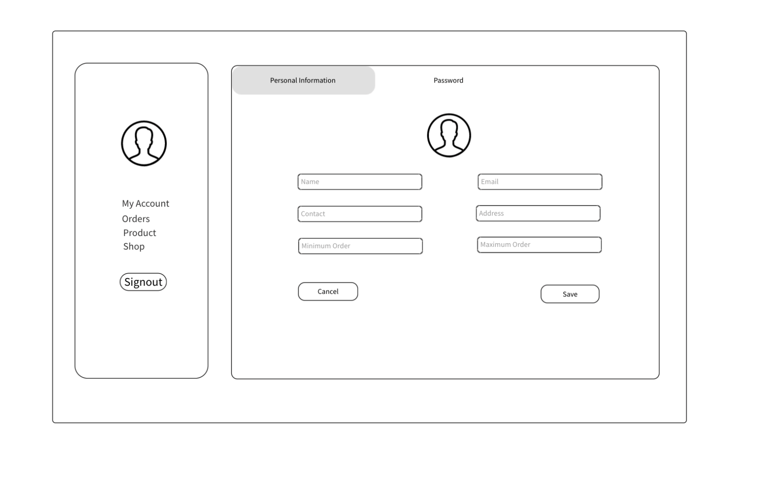

#### Product Update

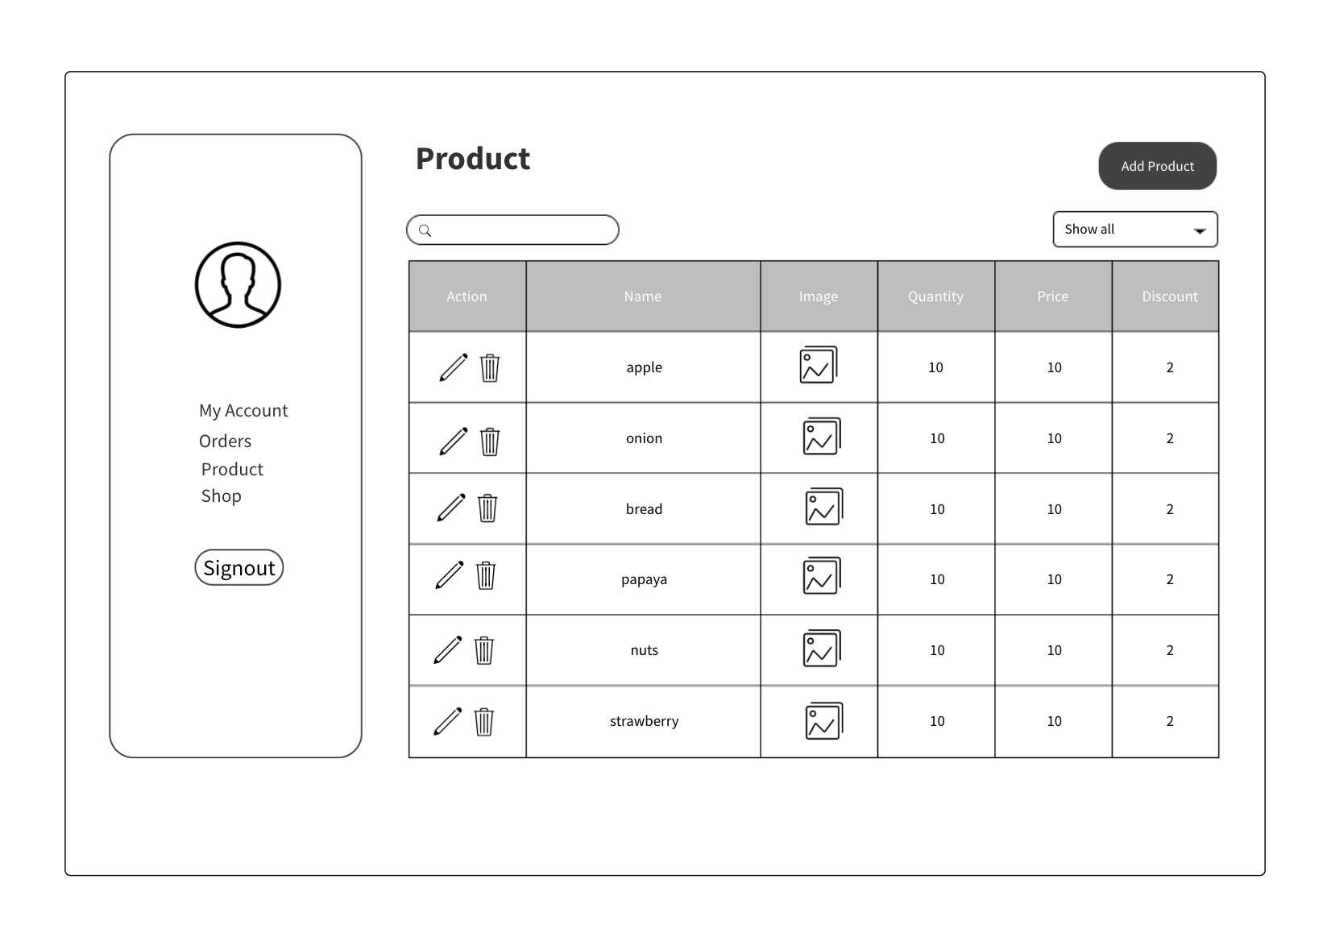

#### Product Details Page



### Admin Interface

#### Dashboard

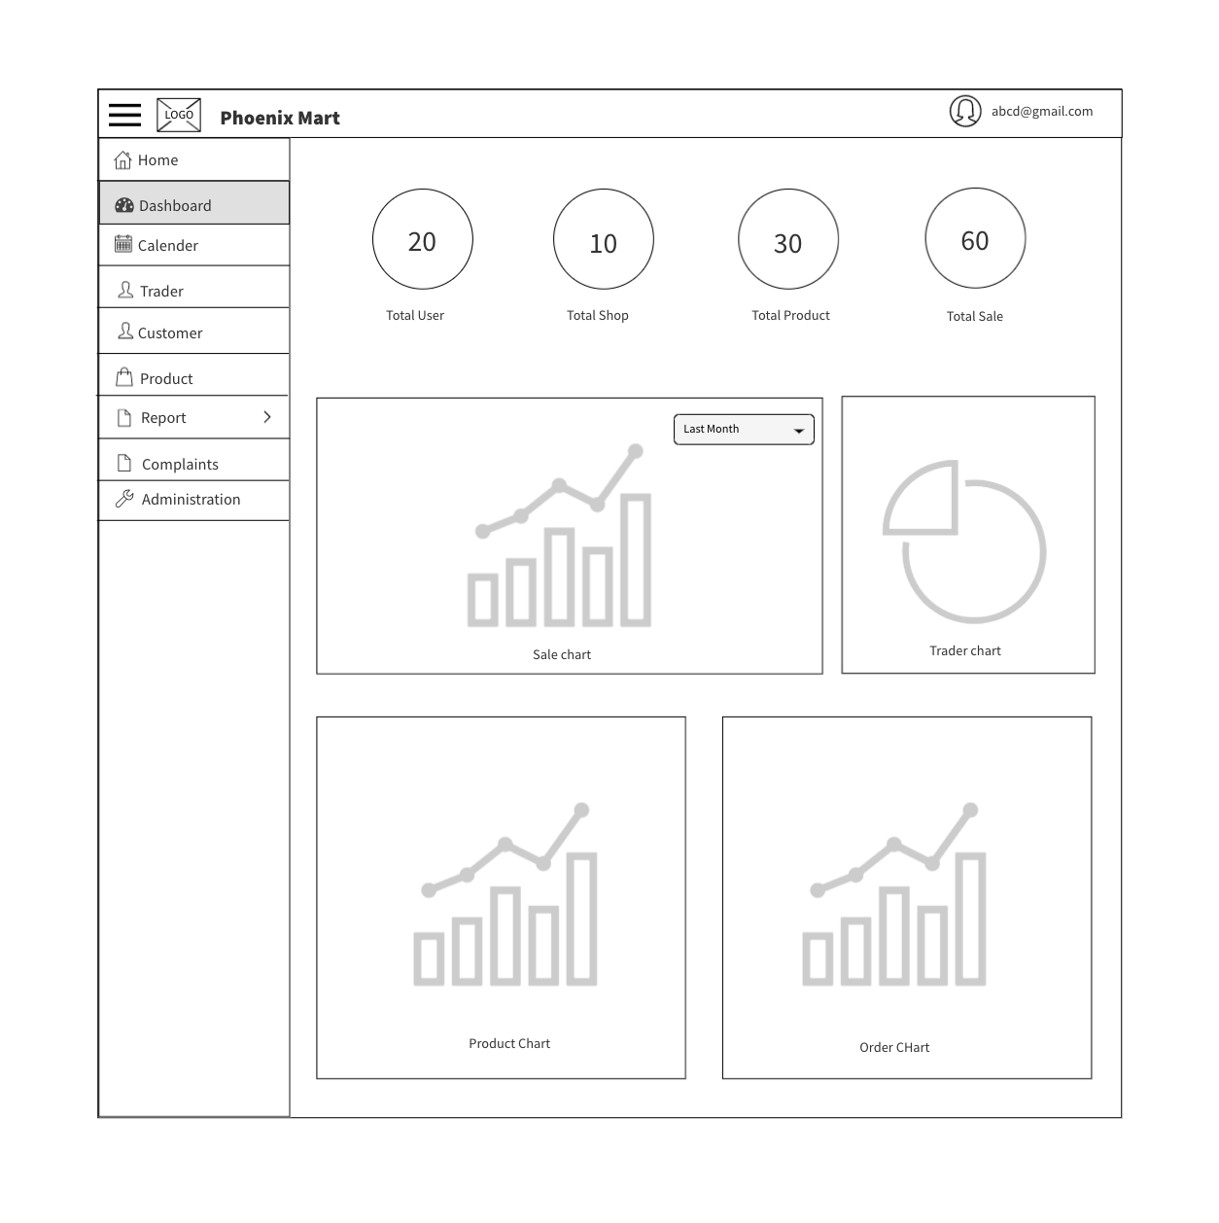

#### Add Trader

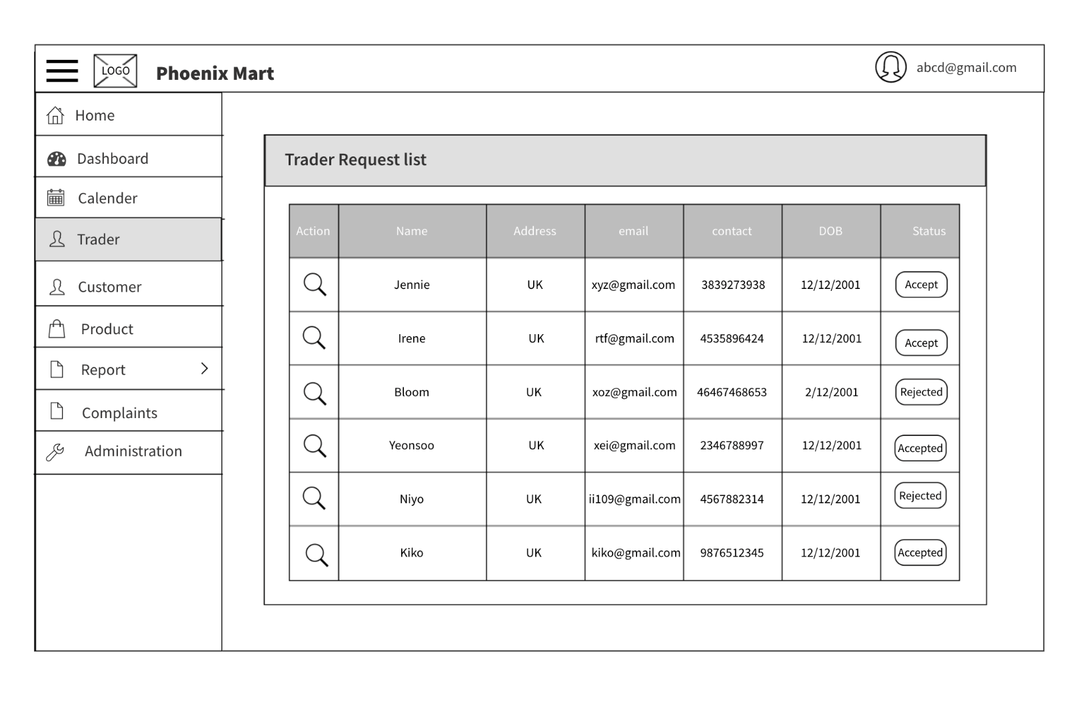

#### Customer Page

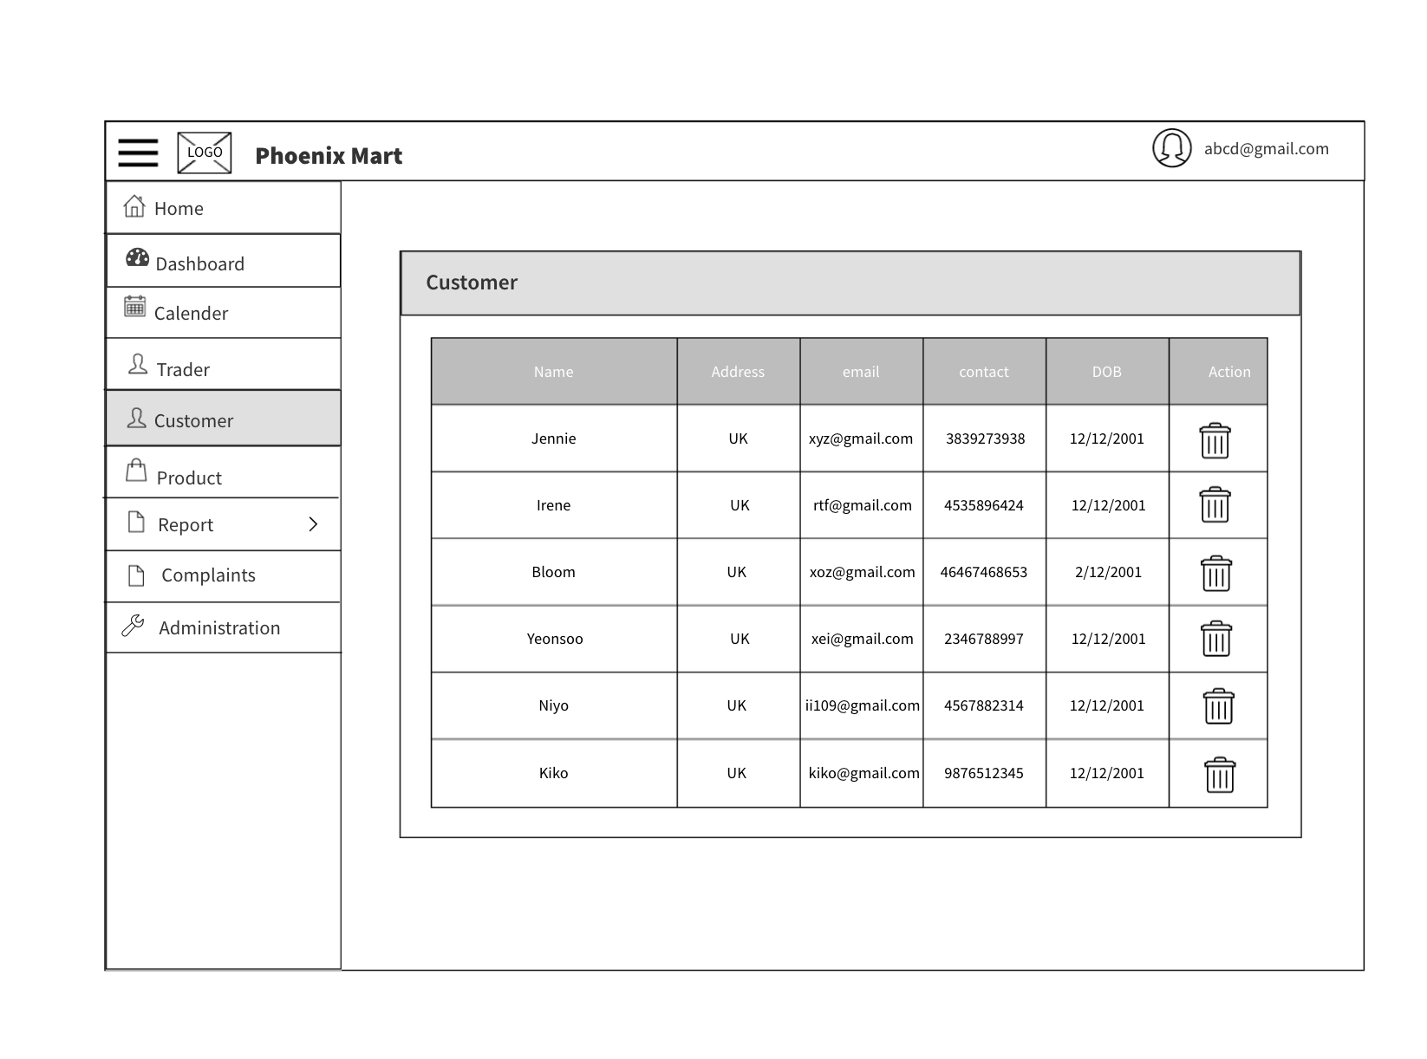

## Product Development

### Homepage

### Login

### Register

### About Us

### Backend

#### Table Creation

